Report on
Short Term Program on
“Innovation and Rejuvenation of Teaching in Higher Education”
held in
Suren Das College, Hajo
February 04 – 09, 2019

Day I (04/02/2019):
The short term program started with inaugural ceremony where Prof. Amarjyoti Choudhury, Vice- chancellor of Down Town University, Guwahati graced the occasion as chief guest. Dr. Hiranya K. Sarma, Principal, Suren Das College delivered welcome address followed by inaugural speech from Prof. Amarjyoti Choudhury. Prof. Choudhury mentioned about the importance of innovation and rejuvenation of teaching in Higher Education and appreciated such kind of ideal workshop for teaching community of Higher education. He also said that being a teacher in the flux of time is not easy, because new topics and ideas are coming. Observer from TLC, TU, Dr. Bhushita Patowari gave a brief objective and overview of the weeklong workshop. The session was ended with vote of thanks by the Coordinator of the workshop Dr. Arup K. Deka, Assistant Professor, Department of political science, Suren Das College, Hajo.
In the 2nd session Prof. Amarjyoti Choudhury discussed on “Quality of an Effective Teacher”. In the session Prof. Choudhury mentioned about various quality of an effective teacher like aids to the mind, builds the basics, crack the walls, eases off with tools, feels the students, goes the totality, harnesses empathy, inspire immensely and judge critically. He also mentioned that teacher is one who teaches. But teaching is what satisfies curiosity and create space for new curiosity. A teacher is one who continues to excite curiosity and inspire to be curious.
Third session was taken by Prof. H. P. Sarma, Rector, Gauhati University on “Best Practices in Higher Education”. In this session Prof. Sarma explored the different aspects of Higher education such as curricular aspects, teaching learning and evaluation, research consultancy and extension, software, governance, leadership and management etc. According to him improving all these aspects and practices will definitely help to build a better higher education platform.
Last session of Day I was Activity on ICT taken by Dr. Bhushita Patowari, Research Associate, Teaching Learning Centre, Tezpur University. In that session participants were introduced with generation of e-resources and screen casting. Participants were also demonstrated to prepare an e-resource and video resource of their respective disciplines using screencast-o-matic software.
Day II (05/02/2019):
The second day was started by the words of Prof. (Rtd) Krishna Gopal Bhattacharyya, Department of Chemistry, Gauhati University. In this session Prof. Bhattacharya discussed about “Student Support” and “Role of Teacher in Institution Building”. He mentioned about various concepts regarding students support in higher education. Those were – career Counseling, placement and future avenues, Student outreach program, Motivation and national integration, Student redressal, Parallel learning, Student mentoring and Role of alumni. He also said that there are three common student support services identified in the higher education institutions, they were - Academic, Career and Psychological counseling. He added about the students’ perception on support services, sstudents’ satisfaction, career guidance, student’ outreach program and its benefit, motivation and national integration.
In continuation of the 2nd session Prof. Bhattacharyya emphasized on role of teachers in achieving the institutional goals and objectives, role of teachers in institutional integrity, institutional community building and cohesion, participation in institutional perspective plans. He also mentioned about the duties and responsibilities of teaching faculty, they should comply with the relevant policies, rules, regulations, norms and standards set to guide their work and while every individual member is accountable for his/her action, as member of the University/College community, they are collectively accountable for upholding those standards of behaviour and for compliance with all applicable rules, regulations and code of conduct. In his deliberation Prof. Bhattacharyya also identifies some concepts likes course planning and material preparation, examination, evaluation and grading, maintenance of records, monitoring of students’ progress, participation in academic developments, punctuality and regularity, academic research, co-curricular activities and summarized the role of teachers in institution building.
Post-lunch sessions were taken by Prof. (Rtd.) Nilima Bhagabati on “Empowering Teacher I and III”. The speaker motivated for career advancement and perspective of career advancement. According to her Discipline, Devotion and Dedication are 3 D’s for a teacher to be empowered themselves. She also mentioned about the importance of the interdisciplinary aspects of teaching and critical thinking. The session was carry forwarded with a group activity of critical thinking and presentation by the participants.
Day III (06/02/2019):
First two sessions were taken by Prof. Padmini B. Boruah, Department of ELT, Gauhati University on “Innovative Teaching Practice I and II”. Here Prof. Boruah clearly explained the metaphor of a classroom. She explained and demonstrated different situations and examples of creating an environment for teaching and learning as an innovative method. Those are think pair shape, brainstorm, buzz group, board group misconception cheek; fishbone, metaphor role play and crossword puzzle. She also emphasized on the role of a teacher regarding students’ engagement in the classroom. Educational innovations emerged in various areas and in many forms. Innovation can be directed towards progress in one, several, or all aspects of the educational system. Overall, the sessions were discussion cum activity oriented sessions.
Prof. (Rtd.) Swarnalata Das, Department of Education. Gauhati University delivered speech on “Evaluation” and “Activity on Test Construction” in the post-lunch sessions. According to Prof. Das, evaluation is always a systematic and predetermined procedure. There are different types evaluation namely – Formative evaluation, Placement evaluation, Diagnostic evaluation, Summative evaluation, Planning evaluation, Process evaluation, Outcome evaluation and Impact evaluation. Although summative and formative evaluations are widely used. She has also emphasized on construction of test. Generally, two types of tests are used in classroom environment – essay type test and objectives type test. Essay type test has extended response and restricted response. Again objectives test has sub-divided as supply test and selection test. The speaker also pointed out the level of difficulties and the procedure how to measure the difficulty level of a question with a group activity of MCQ preparation.
Day IV (07/02/2019):
In the forenoon sessions Dr. Bornali Bhuyan, Associate Professor, Department of English, KRB College, Guwahati delivered on “Empowering Teacher II” and “Teacher and the Society”. In both the session Dr. Bhuyan discussed about understanding inclusion within and beyond the classroom. There are so many different things that our learners could achieve if we give them the chance to do so. She emphasised on the driving principle to make all students feel welcome, appropriately challenged, and supported in their efforts. It is also critically important that the adults are supportive too. The speaker also mentioned about gender sensitivity. As a facilitator we all must have to try to develop gender sensitivity among the students that will create a better environment for learning and education. In this regards the speaker pointed out different views of student community given by the students of various colleges in Guwahati.
The 3rd session Dr. N Amareshwaran, Assistant Professor, Department of Education, NEHU delivered his speech on “Constructivism in Teaching”. The speaker explained the concept of constructivism which is basically a theory based on observation and scientific study about how people learn. He said that people construct their own understanding and knowledge of the world, through experiencing things and reflecting on those experiences. Constructivism is a theory of knowledge, learning, and teaching.
Last session was Activity session taken by Dr, Bhushita Patowari. The session was in continuation of the previous assignment of e-resource and screen casting.
Day V (08/02/2019):
In the 5th day of the program the sessions were taken by the Dr. N. Amareshwaran on “Learner Centric Approach of Teaching”, “Effective Classroom Management” and “ICT based Teaching Learning”. In his discussion Dr. Amareshwaran mentioned about various approached of teaching and learning. According to him, learner is the treasure that will follow its owner everywhere. There are different dimensions of learning that are Learning to Know, Learning to Do, Learning to Be and Learning to Live Together and these four dimensions are related to knowledge.
The speaker discussed about the concept of effective management of class room. According to him, it is a set of principles, beliefs, or ideas about the nature of learning which is translated into the classroom. Teaching Strategy is a long term plan of action designed to achieve a particular goal. Teaching Method is a systematic way of doing something which implied an orderly logical arrangement of steps. It is more procedural. Teaching Technique is well-defined procedure used to accomplish a specific activity or task. Learner Centric Approach is premised on the belief that the learner is also an important resource because he/she also knows something and is therefore capable of sharing their knowledge.
In the last session Dr. Amareswaran demonstrated some e-learning which are available on different portals. Participants were acquainted with self-learning courses.
Day VI (09/02/2019):
In the 1st session Prof. Abani K. Bhagabati, Department of Geography, Gauhati University delivered his speech on “Environment and Sustainable Development”. Prof. Bhagabati mentioned about the upcoming challenges of sustainable development with reference to North-East India. The speaker mentioned about physiographic division, Wetlands and Demography of North-East India along with increasing conflict with nature.
Following two sessions were “Activity on ICT” and “Feedback” taken by Dr. Bhushita Patowari. Creation of Google form was demonstrated and participants also made a Google form in their respective fields. Along with that participants were submitted their e-resources and presented progress of screen casting videos. An overall feedback form was given to the participants to give their views and suggestions for improving the weeklong workshop in near future.
The last session of the short term course was valedictory session. The session was started with welcome and felicitation to the dignitaries, Guest of Honour Prof. Jogen Kalita, Director, HRDC, GU and Chief Guest Prof. Mrinmoy K Sarma, Director, TLC, TU. Welcome address given by Dr. Hiranya K. sarma, Principal, Suren Das College, Hajo. Followed by address from guest of honour, feedback from participants and address from chief guest. Coordinator and observer also presented their overall report of the program. Completion certificates of the weeklong program were distributed by the dignitaries. Vote of thanks given by the joint coordinator and the program came to end with the national anthem.
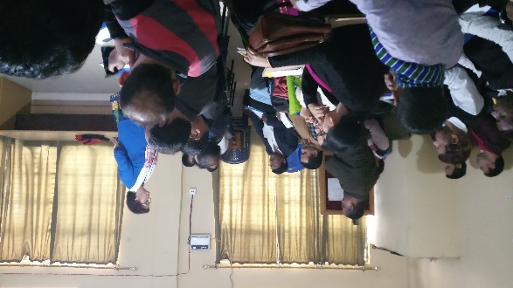
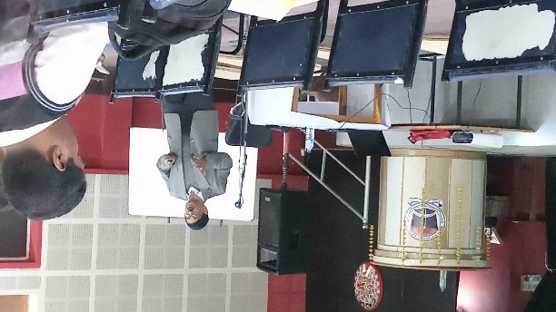
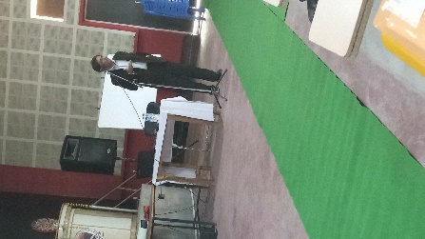
Some glimpses of the workshop:
