Induction Training of Faculty
Round – I
23 November – 22 December, 2017
Teaching Learning Centre, Tezpur University

REPORT

A month long program “Induction Training of Faculty” was organized by Teaching Learning Centre (TLC), Tezpur University during 23 November to 22 December, 2017. Altogether 26 newly inducted faculty members of various disciplines participated in the program. Among them 14 participants were from Humanities, 8 from Science, 2 each from Commerce and Engineering. There were 10 male participants and 16 female participants in the program. The content of the program was prepared according to the guidelines of MHRD that cover different topics related to Higher Education. 47 Resource Persons consisting of Academic Administrators (present and former Vice Chancellors, Directors of Institutions, Registrars, and Controller of Examination), academicians from different disciplines (Science, Management, Engineering, Humanities and Social sciences), Social Activists and Fitness Experts shared rich experiences and insights about being good, effective, motivating teachers who are custodians of values and culture of a society as well as change agents, role of teachers in institution, society and nation building, administrative aspects including procedures and rules. The program also tried to cover some activity like practice teaching, group discussion and presentation. Participants are taken out to field visit to appreciate rural life, cultivation and mighty river Brahmaputra. Feedback for each session was taken separately in online mode. These feedback has been shared with the Resource Persons as well as with the participants. Quick feedback on sessions (compulsorily submitted by the participants before 9.30am of the next day) helped the organizers in moulding the programme with greater effectiveness.

Day I: (23 November, 2017)
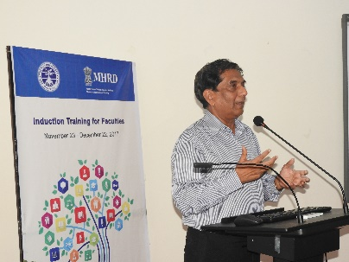
The program started with introduction of participants followed by welcome address by Prof. Mrinmoy K. Sarma, Director, TLC, TU. He gave an overview of the month long program.
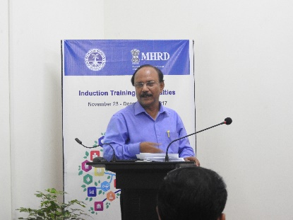
Prof. Amarjyoti Choudhury, C V Raman Chair professor, Applied Science, University of Science & technology, Meghalaya deliberated on “Evolution of Higher Education Sector in India” in the second session. The speaker discussed about evolution of primary to university education along with some of the features of higher education. He also highlighted some of the indicative figures of Higher education. In the third session, Prof. Madan M. Sarma, Vice-chancellor, Tezpur University delivered a speech on “Role of Teacher in Society”. Prof. Sarma discussed the traditional role of teachers as facilitators of learning. He also mentioned that role of teacher had been changed to transmission of intellectual tradition. In the same context professionalism and ethics had also been discussed. In the last session Prof. Amarjyoti Choudhury discussed about “Contribution of Universities to Higher Education”. In this session the speaker discussed about cultural movement, evolution and roll of renowned universities around the world.
Prof. Amarjyoti Choudhury
Prof. Madan M. Sarma
Prof. Amarjyoti Choudhury
Day II: (24 November, 2017)
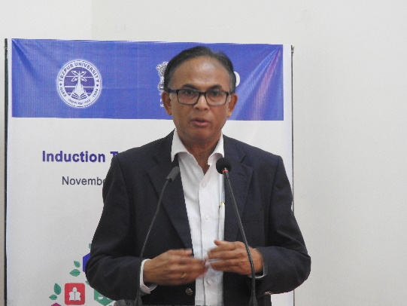
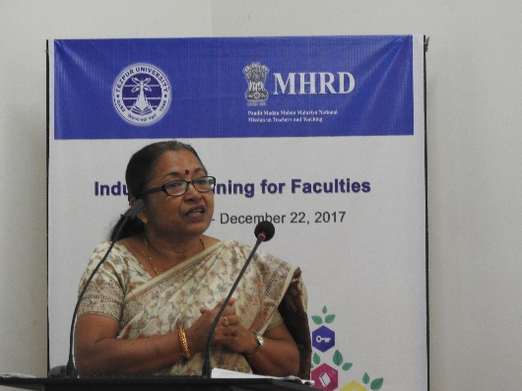
In the 1st session Prof. Charulata Mahanta, Dean, School of Engineering, Tezpur University delivered a speech on “University’s Vision and Mission”. The speaker explained why a university should have vision and mission, what does it mean, and that mission and vision should align with each other. It should put up in a prominent place to keep it at the forefront of our mind. Review mechanism could be there so that progress could be recognized. She also discussed about Tezpur University’s mission and vision elaborately along with identified target, and the strategy for achieving the targets.
Prof. A. K. Buragohai
Prof. Charulata Mahanta
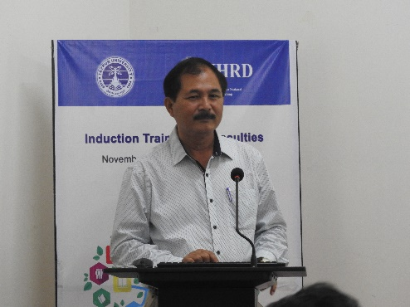
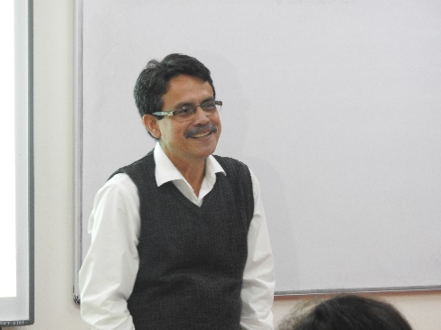
In the 2nd session Prof. A. K. Buragohain, Vice-chancellor, Dibrugarh University delivered his speech on “Challenges in Learning Environment”. He explained that there are changes in higher education with the changes in time. He mentioned that from the inception, the higher education institutions have been in process of gradual changes from pen & paper to digital system. He suggested that we should find out innovative way of teaching as well as evaluation system so that students’ performance can be uplifted to ICT enabled learning instead of parrot learning or copying. In the 3rd session Dr. Rajeev K. Doley, Director, Centre for Inclusive Development, Tezpur University, delivered his speech on “Teaching Profession and Public Relation”. The speaker mentioned How public relation starts, what exactly public relation is, role of public relation in Indian independence and public relation in an organization. The speaker emphasized on strong inter personal relationship, employer branding, bridging the gap, performance measurement along with certain important responsibilities. He had also given importance to measure outcome, not to measure output.
Dr. Rajeev K. Doley
Prof. Robin K. Dutta
In the last session Prof. Robin K. Dutta, Department of Chemical Sciences, Tezpur University delivered his speech on “Interdisciplinary Integration”. The speaker discussed about interface and Interdisciplinary education. In that session interdisciplinary studies were discussed with reference to world war II, public health, Brahmaputra etc. He also mentioned about how to integrate with personal experience of interdisciplinary areas with some real life examples.
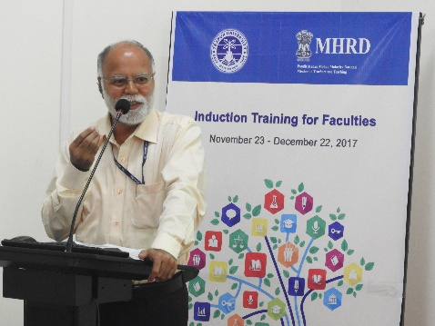
Day III: (27 November, 2017)
Prof. N. C. Talukdar
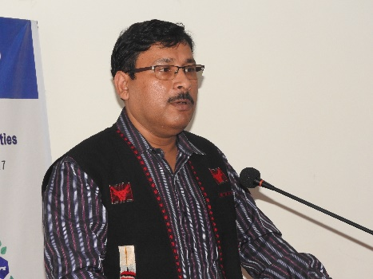
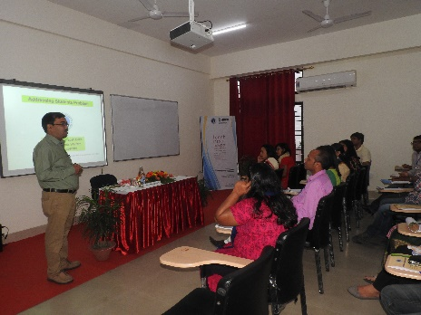
In the 1st two sessions taken by Prof. N. C. Talukdar, Director, Institute of Advanced Studies in Science & Technology (IASST), Guwahati, the focus was on “Integration of Teaching and Research in Higher education”. The speaker explained with different examples of science that how teaching and research are integrated, where both can be pursued simultaneously which will result good impact on student accordingly. Students will be benefitted more as well as the teacher is opening different branches for further study. He also mentioned about student research and research based student learning for all student at all higher institutions. This integration is also influenced by environment. In the 3rd session Prof. A. K. Mukherjee, Dean, Research & Development, Tezpur University delivered his speech on “Research Proposals & Research Administration”. Main idea of his topic was how we can write a good proposal to triumph over the challenges and make significant progress in our research? And what we do need to understand that most of the research grant is supported by Govt. funding agencies by using public money. The speaker discussed about the relation of researcher, institute and funding agency. He gave a brief idea about different funding agency in India. Some of the important points while writing research proposal like justified region, rechecking the proposal with specialized person, collaboration etc. mentioned by the speaker. While writing project proposal one of the important thing is formulation of project proposal. He also discussed about different steps, mistakes commonly noticed and selection of funding agency in writing project proposal.
Prof. A. K. Mukherjee
Prof. Dhanapati Deka
In the last session of the day Prof. Dhanapati Deka, Dean, Student Welfare, Tezpur University has taken a session on “Addressing problems of students”. In the session Prof. Deka mentioned about students’ problems, students discipline process, welfare process and science of behaviour. He also discussed about different strategies to address the problems of students.
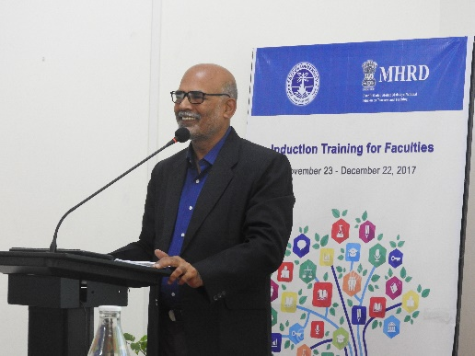
Day IV:(28 November, 2017)
Dr. Biren Das
In the first session Dr. Biren Das, Registrar, Tezpur University delivered a speech on “Administrative Leadership”. He mentioned that there is excellence in our objective and how to promote excellence in higher education institutes. Also mentioned about measuring sticks – ranking of universities, NAAC, Grading, NBA, Accreditation. Dr. Das also discussed about problems or factors which create hurdles in excellence like resource crunch, limited excess, problem of equity, lack of quality and autonomy-academic.
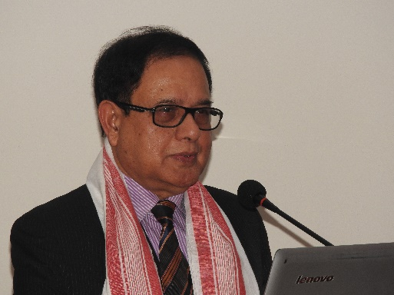
Prof. K. K. Deka, Vice-chancellor, Mahapurusha Srimanta Sankaradeva Viswavidyalaya, Nagaon delivered his speech in the 2nd session on “Role of Universities in Inclusive Development”. The speaker explained what is inclusive development, its importance in higher education sector along with some statistics of higher education scenario. On the basis of the available statistics it is clear that we have not achieved yet the goal in higher education.
Prof. K. K. Deka

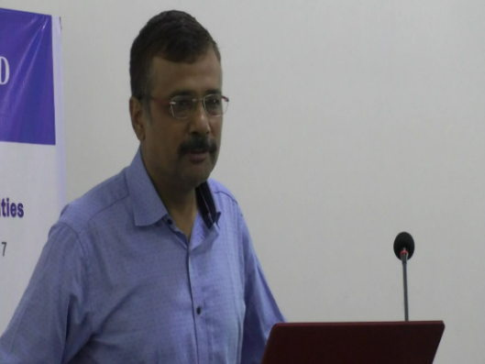
In the 3rd session Prof. Mrinmoy K. Sarma, Director, Teaching Learning Centre, Tezpur University discussed on “Research Methodology”. Where Prof. Sarma discussed and interacted with the participants about different aspect of academic research. Last session was an activity session where participants were divided into 4 groups. Two situation were given to them – i) most embarrassing moment and ii) most challengeable moment as a teacher. They were asked to discuss within their group and wrote on any one topic.
Prof. Mrinmoy K. Sarma
Day V: (29 November, 2017)
Dr. Biren Das delivered the 1st session on “Role of Academic Officers in Higher Education”. In the session the speaker discussed about administration of higher education along with mandates, authorities of higher education institutes, academic officers and their power and functions.
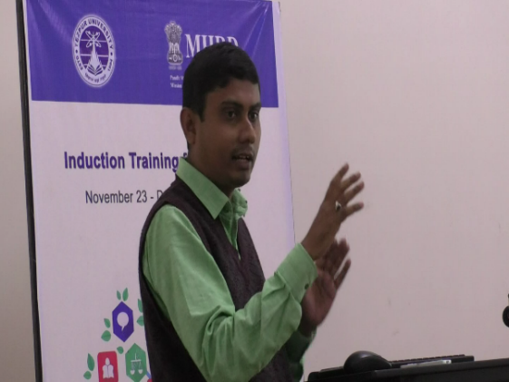
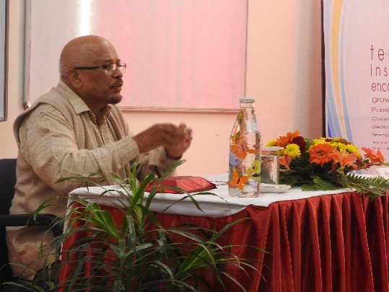
In the 2nd session Prof. Virginius Xaxa, Department of Sociology, Tezpur University delivered his speech on “Education Reforms of 21st Century”. In his speech the speaker mentioned that education is smooth functioning of society and is trying to catch up transformation. Prof. Xaxa discussed about education policy and ratio of educational institutions with respect to population. He also mentioned that there has been an expansion in education after 1986 but the quality also matters, considering the example of right to education which is an educational reform but what are the accessibility, what about quality, about problem i.e. number of things have been introduced from time to time. He also mentioned that one of the problem is poor enrolment ratio, dropout rate etc. He added that primary education is also very important in reforming higher education which we cannot deny.
Dr. Suvam Sen
Prof. Virginius Xaxa
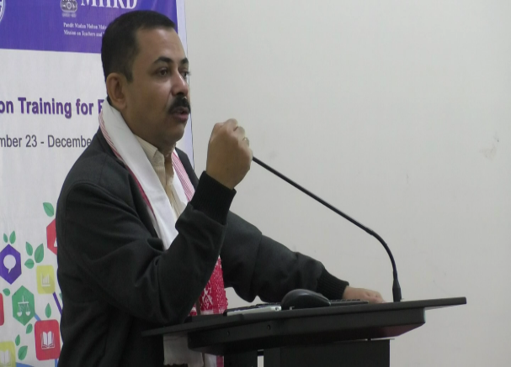
In the post lunch session Dr. Suvam Sen, Associate Professor, Department of Mathematical Sciences, Tezpur University delivered his speech on “Participation in Extension Activities”. Dr. Sen discussed about Tezpur University outreach program, different opportunities and challenges in outreach program. A good number of faculty members and research scholars of the University became part of it. They conducted different program to aware about basic science, social science, health and healthy social life. The session ended with small activity of writing a model for future extension activities.
Prof. Utpal Sharma
In the last session activity of writing personal experience on two topics was continued from previous day. They discussed about those problem and summarized within the group.
Day VI: (30 November, 2017)
Prof. Utpal Sharma, Department of Computer Science and Engineering, Tezpur University delivered his speech on “National Academic Governance: UGC, NAAC and NIRF”. Prof. Sharma discussed about education framework, education objectives, education standard and education evaluation. During the session sustainability of funding and governance, function, roles and mandate of UGC, inter university centres were also discussed.
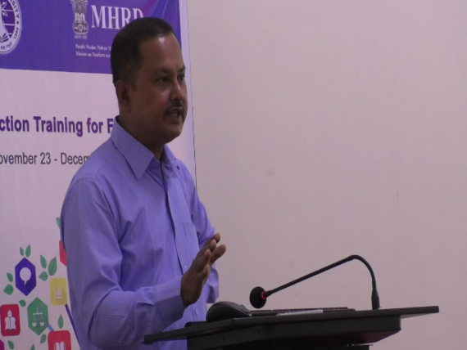
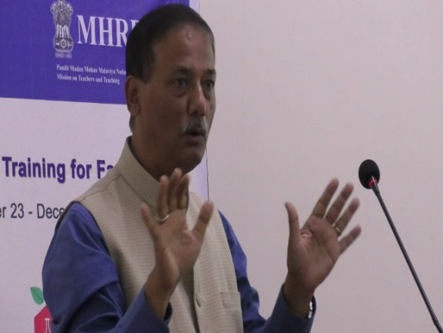
In the 2nd session Dr. Mukesh Saikia, Librarian, Tezpur University delivered his speech on “National Academic Communication: CEC and INFLIBNET”. He discussed about academic communication, transmission of academic information, internet communication, casual communication and consortium for educational communication. Multimedia research centres, e-learning, e-content, digital media library, EDUSAT network, information & library network centre, infonet digital library consortium, NLIST and role of modern library in academic communication has also been discussed.
Prof. Manabendra Bhuyan
Dr. Mukesh Saikia
In the post lunch session Prof. Manabendra Bhuyan, Department of Electronics and Communication Engineering, Tezpur University delivered on “Conducting Research and Publications”. In that session Prof. Bhuyan discussed about research contribution, prime objective of research, research process, standard & acceptance of research, publication regulation, citation and plagiarism.
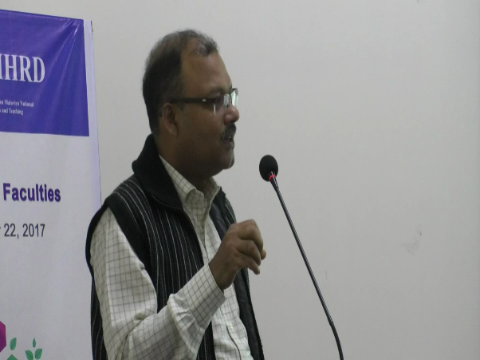
In the last session Prof. Debabrata Das, Department of Business Administration, Tezpur University delivered a speech on “How to Publish”. The speaker mentioned about various aspects of publication like why we need to publish. He added that the whole process of publication is not so easy. He gave a framework of publication, paper writing model and ethics in academic writing.
Prof. Debabrata Das
Day VII: (1 December, 2017)
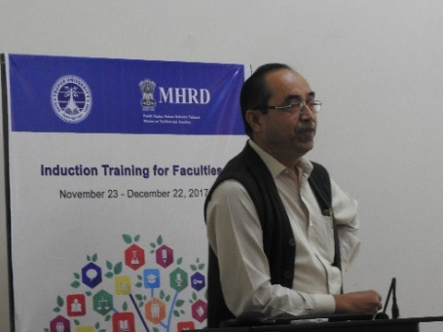
In the morning sessions, Prof. Dilip K. Saikia, Department of Computer Science & Engineering, Tezpur University delivered a speech on “University Structure and Authority” and “University Act, Statutes and Ordinances”. In his speech Prof. Saikia mentioned about University’s mission, entities, different categories, new classes of universities and typical structure of universities like academic unit, governance, administration, support services etc. He also explained each component of structure of university and detail of Tezpur University Act.
Prof. Dilip K. Saikia
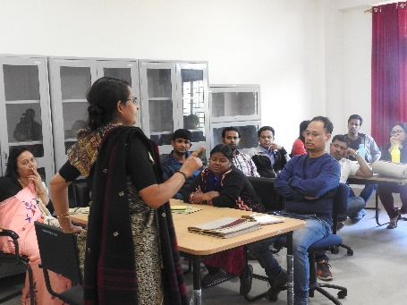
In the post lunch session Dr. Madhurima Goswami, Associate Professor, Centre for Women Studies, Tezpur University discussed about “Gender Sensitivity”. She discussed about importance of gender sensitization and why it is needed. The speaker also discussed about importance of the topic in educational institution with reference to teacher student interaction.
Dr. Madhurima Goswami
A small activity on “Teaching as a profession” and “teaching & passion” was performed by all participants.
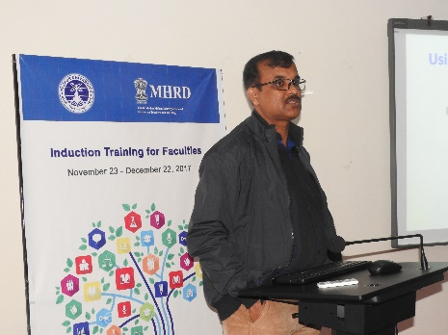
In the last session Prof. Nityananda Sarma, Departement of Computer Science & Engineering, Tezpur University delivered his speech on “Using Digital Tools in Teaching”. The speaker discussed about Trends in Teaching-Learning, Education Technology, Flipped classroom, Social media in classroom, Security and privacy issues, Mobile Learning, Video conferencing tools, Web conferencing tools and advantages of using digital tools in teaching.
Prof. Nityananda Sarma
Day VIII: (4 December, 2017)
Prof. Nashreen S. Islam
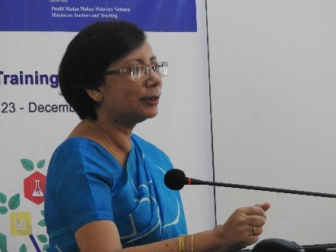
Prof. Nashreen S. Islam, Chemical Sciences, Tezpur University discussed about “Research Funding in India: An Overview of the Existing Opportunities” in the 1stsession. The speaker explained about areas which covers under UGC for research and research projects (both minor & major). She also mentioned about funding guidelines of ICSSR, ICHR, MATRICS, Startup Research Grant (young scientists) and DBT.
In the 2nd session, Dr. Khireswar Borah, Associate Professor, Arya Vidyapeeth College (President of Assam College Teachers’ Association) delivered a speech on “College Structure and Administration”. He discussed about different committee and commission of education policy, regulatory system and leadership training. He also focused on current situations of govt. colleges in Assam.
Post lunch sessions were activity session where Mr. Partha Barthakur, ICT entrepreneur, Jorhat conducted ICT classes on “Prezi and Screencast” in the ICT lab.
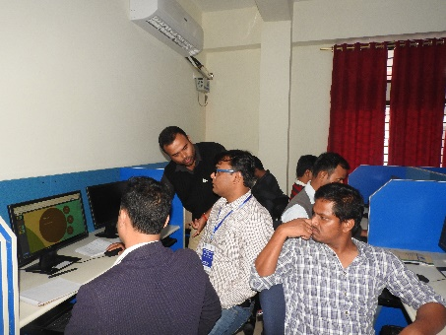
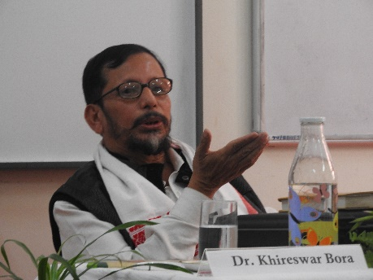
Dr. Khireswar Borah
Mr. Partha Barthakur

Day IX:(5 December, 2017)
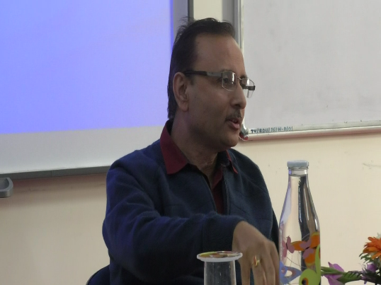
Dr. Lakhi Boral, COE, Tezpur University delivered his speech on “Choice Based Credit System”. In the session Dr. Boral discussed about importance of CBCS, various problems and some of advantages of the system. He added that it is a step towards interdisciplinary approach of learning.
Dr. Lakhi Boral
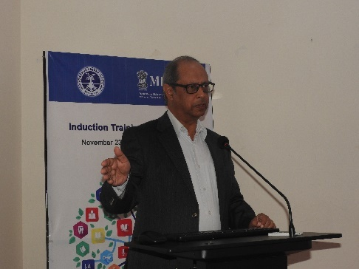
In the 2nd session Prof. Prasanta K. Das, Dean, School of Humanities & Social Sciences, Tezpur University discussed on “Current Trends of Global Higher Education”. In his speech Prof. Das focused on Global Ranking which is influenced by teaching, research, citation, income from industry and international outlook. He also explained what are the important factors for international outlook of an Institution as it has a very significant role in global ranking.
Prof. Prasanta K. Das
Post lunch sessions were taken by Prof. Mukul K. Sarma (Rtd), Department of Education, Dibrugarh University. In these two sessions Prof. Sarma discussed about “Gestalt Psychology in Teaching and Learning” and “Subject based Assessment Method”. The speaker discussed about working principles of Gestalt psychology along with structure and domain of learning.
Prof. Mukul K. Sarma
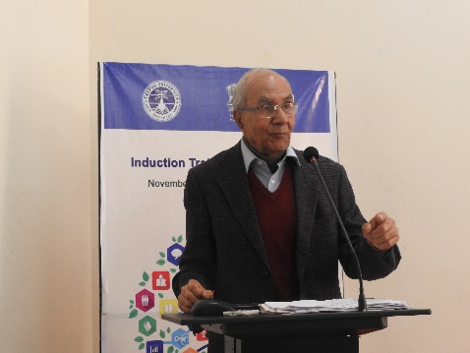
Day X: (6 December, 2017)
Pre-lunch sessions were taken by Prof. Mukul K. Sarma where the speaker discussed about “Syllabus and Curriculum Development” and “Teaching in 21st Century – Learners and Teachers”. He mentioned about different strategies of learning methods for learners as well as for teachers also. Prof. Sarma also noted that education for 21st century should be learning to learn, learning to do, learning to be and learning to live together.
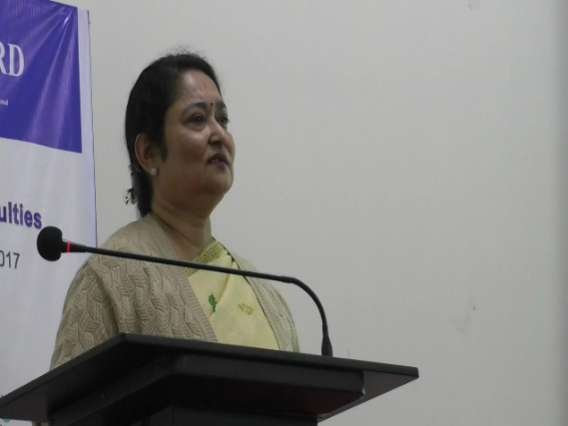
Post-lunch sessions were taken by Prof. Chandana Goswami, Dean, School of Management Sciences, Tezpur University. In these sessions Prof. Goswami discussed about “Communication Skills” particularly what does it mean, how it starts and mode of communication. Exercises on oral communication and written communication were also performed with the participants.
Prof. Chandana Goswami

Day XI: (7 December, 2017)
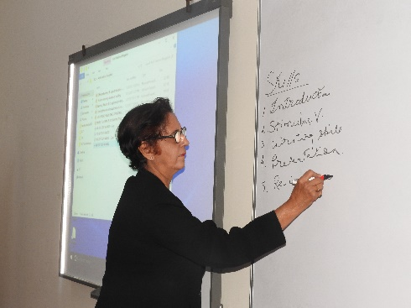
In the 1st session Prof. Nilima Bhagawati, Professor & HoD, Department of Education (Rtd), Gauhati University delivered her speech on “Effective Teaching and capacity Building”. During the session Prof. Bhagawati discussed about effective teacher, dimensions of teacher effectiveness, different parameters of effective teachers and strategies for effective teaching.
Prof. Nilima Bhagawati
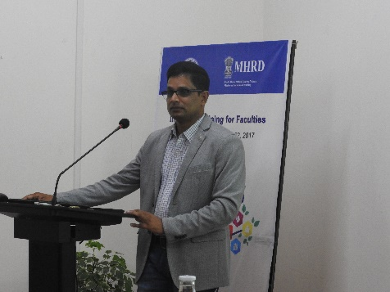
In the 2nd and 3rd session Dr. Nil Ratan Roy, Associate Professor, Department of Education, Tezpur University discussed about “Educational Objectives: Level of Learning” and “Micro Teaching”. During the sessions Dr. Roy discussed about taxonomy of educational objectives, defective teaching learning process, how learning happens, different changes in teacher and student role and micro teaching cycle.
Dr. Nil Ratan Roy
In the last session Prof. Nilima Bhagawati discussed on “Learning Theories and Its application in the Classroom”. During the session major theories of learning, learning model, classroom application and impact on learners were discussed.
Day XII: (8 December, 2017)
Pre-lunch sessions were taken by Prof. Nilima Bhagwati on “Micro Teaching and Developing Teaching Skills”. The speaker explained what is micro teaching, specific objective of micro teaching and skill of Stimulus variation. After that conducted a micro teaching session with the participants. Each participant involved explaining their own disciplines.
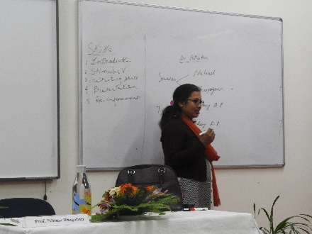
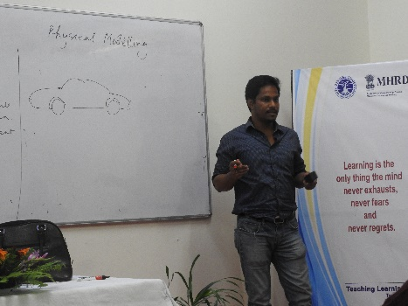
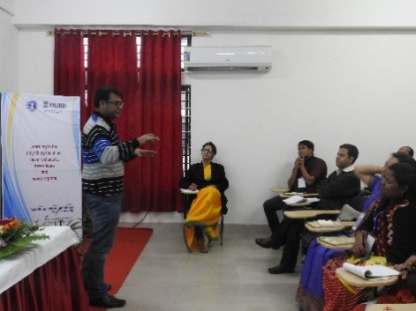
Post-lunch sessions were taken by Dr. Nil Ratan Roy on “Curriculum Evaluation” and “Curriculum Design”. The speaker discussed about need for evaluation, Micro and Macro level of Curriculum Evaluation, Conceptual framework of curriculum cycle, Sources of curriculum evaluation and Aspects of Evaluation. He also mentioned about Components/elements of curriculum design, Sources of curriculum design, Design dimension considerations, Guidelines for curriculum design and Classification of curriculum design.
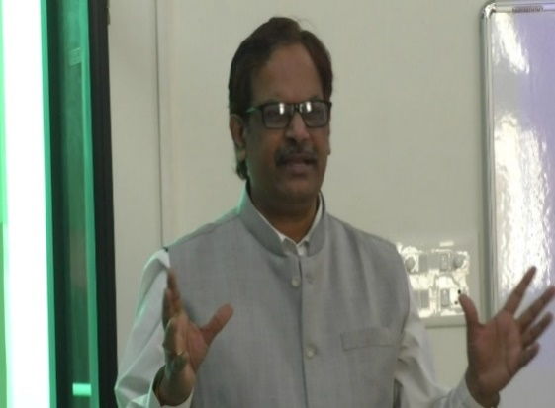
Day XIII: (11 December, 2017)
Prof. K. Srinivas
Prof. K. Srinivas, National University of Education Planning & Administration, New Delhi delivered his speech on “Online Teaching Learning assessment with Open Educational resources, Educational Technology Tools & free Open Source MOOC Delivered Platform”. During the session Prof. Srinivas discussed about SWAYAM and MOOCs. He also mentioned about SWAYAM Prabha, National Digital Library of India, e-shodh Sindhu, blended classroom and online classroom. The speaker also demonstrated how to create MOOCs site to all participants in the ICT lab. In the other session the speaker discussed about “Collaborative Learning”, “Flipped Learning” and “MOOCs”. Post-lunch sessions were activity sessions on the above mentioned learning procedures taken by Prof. Srinivas.
Day XIV: (12 December, 2017)
In the 1st session Prof. K. Srinivas gave a quick look on previous day’s activity and summary from the participants about learning outcome, value addition along with short term & long term plan of their own. In the 2nd session “Video Content Creation” was taught by Prof. K. Srinivas.
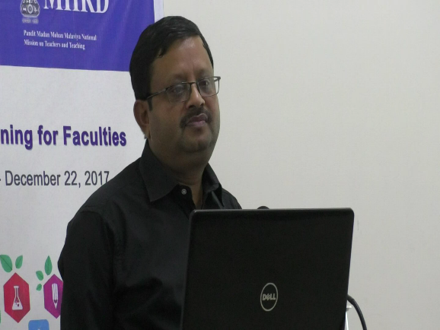
Post-lunch sessions were taken by Prof. S. S. Sarkar, Head, Department of Commerce, Tezpur University on “Key Strategies and Skills for Effective leadership” and “Career Advancement”. The speaker shared his thought about the traits of leader, situational leadership and different ways of assessing staff. An activity of determining the types of leadership was also done with the participants.
Prof. S. S. Sarkar

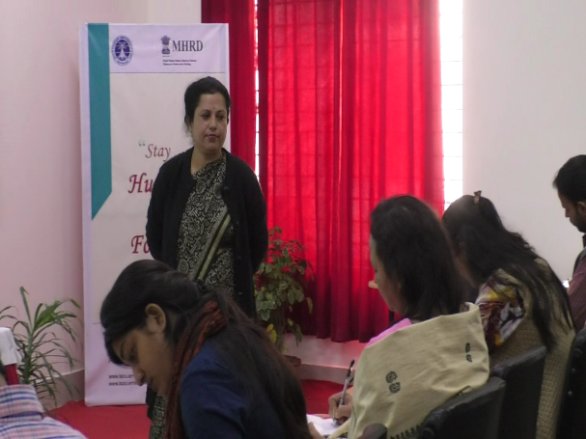
Day XV: (13 December, 2017)
Prof. Papori Baruah
In the 1st session Prof. Papori Baruah, Head, Department of Business Administration, Tezpur University discussed about “Time Management and Work-life Balance”. The session has been taken through small activities which shows different scoring level of participants regarding their management and balance of work-life.
2nd session was an interactive session with the Director of TLC, TU regarding the completed sessions and feedback cum discussions with the participants.
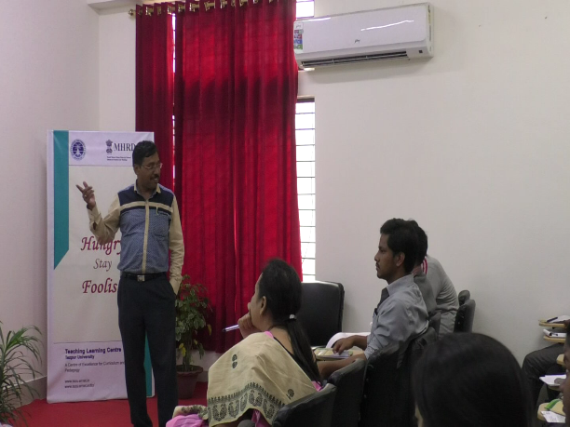
In the 3rd session Prof. Ramesh C. Deka, Dean, School of Sciences, Tezpur University delivered his speech on “Publication and Plagiarism”. The speaker discussed about importance of publication of research article and plagiarism. He also mentioned that why plagiarism is important now a days and put forwarded his thought regarding creative writing.
Prof. Ramesh C. Deka
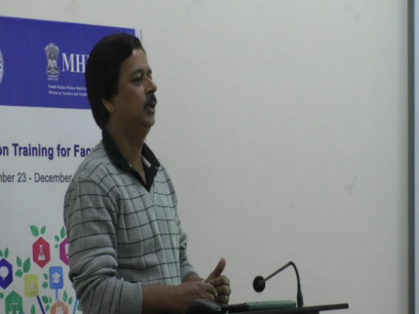
The last session was taken by Prof. D. K. Bhattacharyya, Dean Academic Affairs, Tezpur University on “Cyber Security”. The speaker emphasized on importance of cyber security during digital learning days. As we are more dependent on online portals, ICT tools; knowledge of cyber security is also very important while using different tools for learning.
Prof. D. K. Bhattacharyya
Day XVI: (14 December, 2017)
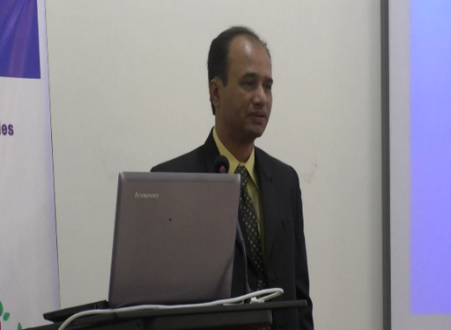
Dr. Tridib Ranjan Sarma, Associate Professor, Department of Business Administration, Tezpur University delivered his speech on “Evaluation & Grading” in the 1st session. The speaker explained in detail how to evaluate and grade in the final semester examination. He also mentioned about a sequence of evaluation.
Dr. Tridib R. Sarma
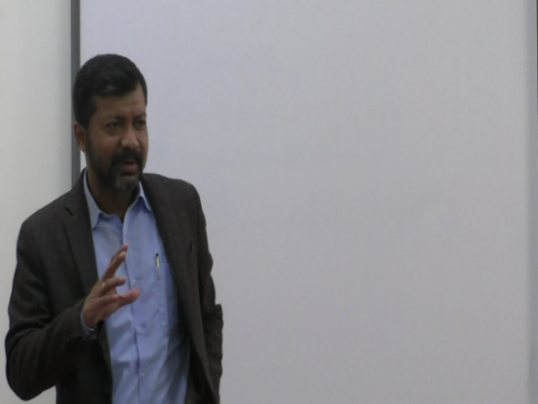
In the 2nd session Prof. Chandan K. Srama, Head, Department of Sociology, Tezpur University delivered his speech on “Organization Culture and Participation”. Prof. Sarma discussed about education system in context of culture from colonial to modern era. Also the culture of institution and healthy practices in culture of institution was put forwarded by the speaker.
Prof. Chandan K. Sarma
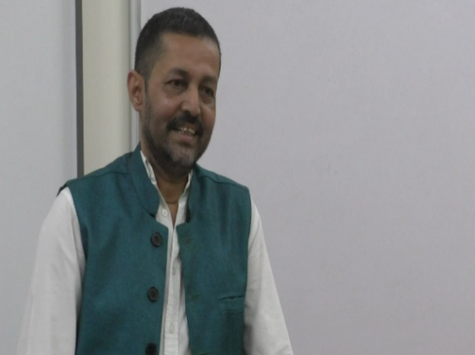
Dr. D. J. Chaudhury

In the post-lunch session, Dr. D. J. Chaudhury, COE, Gauhati University delivered a speech on “Choice Based Credit System” particularly for state level colleges. He also discussed about the difficulties and constraints of the system. The speaker added that assessment of student is very important for making a smooth system of education.
In the last session Dr. Biren Das discussed about “Official Communication”. How to make official communication in a proper way as it is very important for learners as well as teachers.
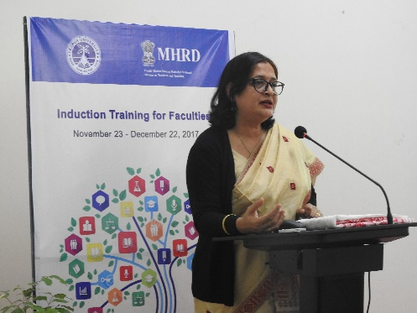
Day XVII: (15 December, 2017)
Prof. Neeta K. Baruah
Pre-lunch sessions were taken by Prof. Neeta K. Baruah, Department of education, Dibrugarh University on “Student Psychology and Teacher Student Relationship” and “Constructivism and Educational Pedagogy”. The speaker mentioned about importance of learning student psychology and their cognition of learning. She also pointed out that it is a theory based on observation and scientific study that how people learn which says that people construct their own understanding and knowledge of the world, through experiencing things and reflecting on experiences. She also explained about learning pyramid.
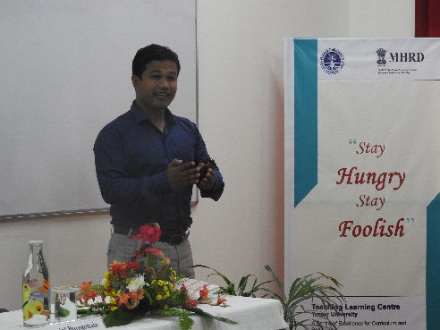
In the post-lunch session Dr. Pranjal Buragohain, Assistant Professor, Department of education, Dibrugarh University (social activist) has taken an interactive session on “Self-awareness and Emotional Intelligence”. In the session the speaker mentioned about importance of emotional intelligence with respect to positive emotions. These positive emotions are very helpful to encourage students and teaching learning procedure.
Dr. Pranjal Buragohain

Day XVIII: (18 December, 2017)
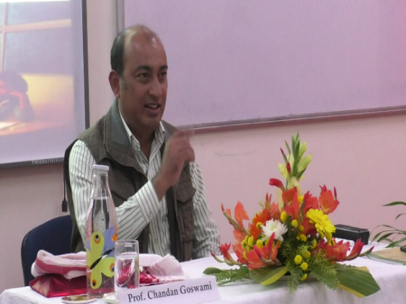
1st session was taken by Prof. Chandan Goswami, Department of Business Administration, Tezpur University on “Effective Ways of Making a Class Interesting”. The speaker discussed about active learning and how to make a class interactive one instead of traditional one sided lecture method. The session was an interactive session as participants were asked to give their opinion on those things that they do not like during their school/college time as a student.
Prof. Chandan Goswami

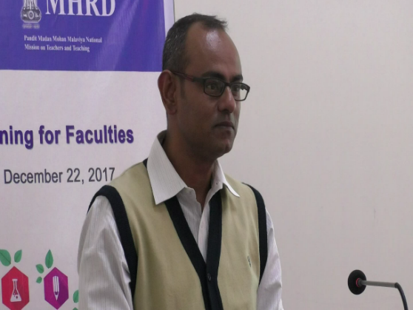
The 2nd session was taken by Mr. Kumarjit Dutta, Deputy Registrar (Finance), Tezpur University on “Financial Rules and Regulations”. The speaker mentioned about financial administration and budget in academic institutions.
Mr. Kumarjit Dutta
In the post-lunch session Prof. Kaberi Saha, Department of Education, Gauhati University discussed on “Lesson Plans: Reflective Practice and Tacit Knowledge”. In the session the speaker discussed elaborately about lesson plan and purposes of it with examples. In the next session Prof. L. R. Saikia, Department of Education, Gauhati University discussed about “Conventional, Non-conventional and innovative Methods of Teaching”.

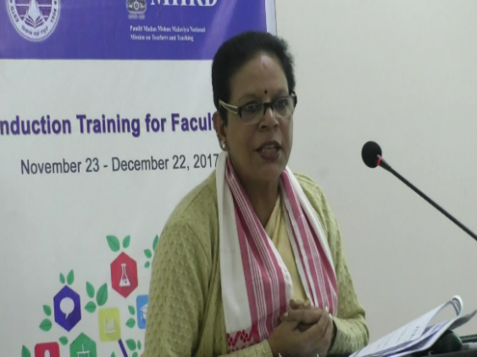
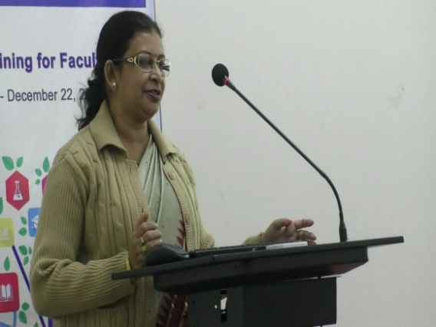
Prof. L. R. Saikia
Prof. Kaberi Saha

Day XIX: (19 December, 2017)
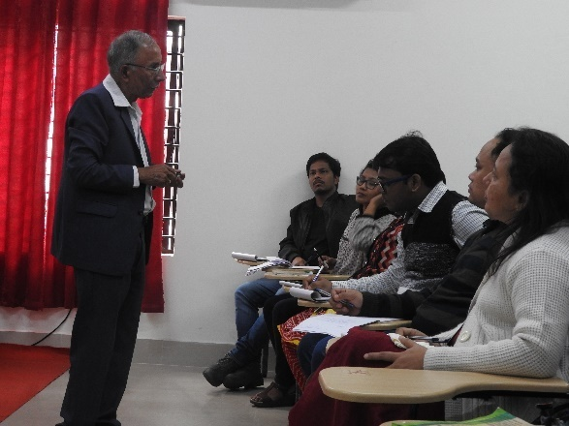
Pre-lunch sessions were taken by Prof. Kaberi Saha and Prof. L. R. Saikia on “Multisensory Teaching Learning Materials” and “Brainstorming” respectively.
Dr. Satish Bhattacharya
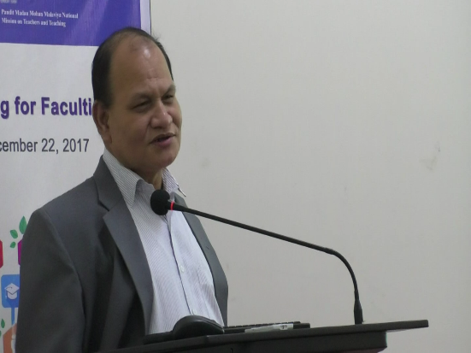
In the post-lunch sessions Dr. Satish Bhattacharya, Former Vice-principal, Darrang College, Tezpur delivered his speech on “Society, Local Culture and Heritage”. He discussed about the role of Assam Research Society, Asiatic Society and Kamrup Anusandhan Samiti. Also discussed about Assamese culture and heritage with special reference to Tezpur.
Prof. B. K. Konwar
Day XX: (20 December, 2017)
In the first 2 sessions Prof. B. K. Konwar, Department of MBBT, Tezpur University delivered his speech on “Visionary Leadership in Higher Education” and “Role of Academic Heads on Enhancing Higher Education”. The speaker mentioned about status of higher education in India. Some of the glimpses of world’s ancient institutes of higher education has also been given by the speaker.
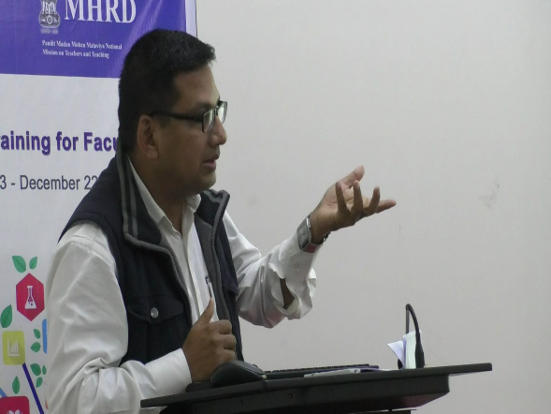
He pointed out limitation of higher education, barriers to academic leadership, characteristics of good leader and leadership framework.
Dr. Anjan Bhuyan
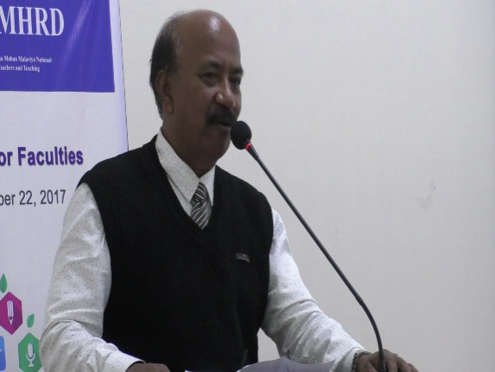
3rd session was an Examination (MCQ) for the participants. In the last session Dr. Anjan Bhuyan, Associate Professor, department of Business Administration, Tezpur University delivered a speech on “Stress Management”. He discussed about what is stress, illusion of stress and how to overcome from stress as it impacts on our day to day performances. To live a healthy life, we have to overcome from stress.
Mr. Pankaj Bora
Day XXI: (21 December, 2017)
In the pre-lunch sessions participants were asked to attend Convocation of the University. In the post-lunch session Mr. Pankaj Bora, Fitness Expert, Tezpur discussed on “Physical Fitness”. He discussed about history and importance of physical fitness, various pioneer in different physical activity and added that physical exercise keeps us active.
Day XXII: (22 December, 2017)
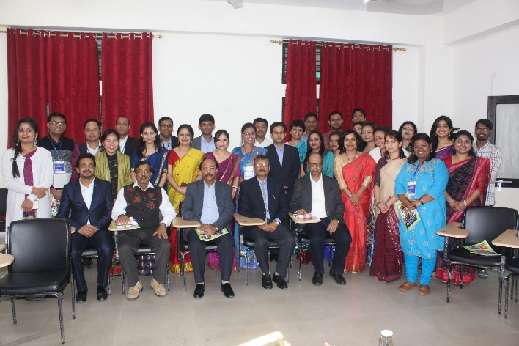
In the last day of the training program 1st session was feedback session where participants were given to fill up a general feedback form where they gave their opinion on overall Induction Training followed by valedictory. The session was chaired by Prof. M. M. Sarma, Vice-chancellor, TU along with Registrar Dr. Biren Das, Chairperson of Advisory Committee Prof. P. K. Das, Director, IQAC of TU Prof. D. C. Baruah and Director, TLC, Prof. M. K. Sarma. The program came to end with distribution of certificates by distinguished guests and vote of thanks by Dr. Swapnarani Bora, Assistant professor, TLC.

