Report on the one-week workshop on
“Decoding Social Media: Dynamics, Uses and Abuses”
organised with
Department of Mass Communication and Journalism
February 11 – 17, 2019

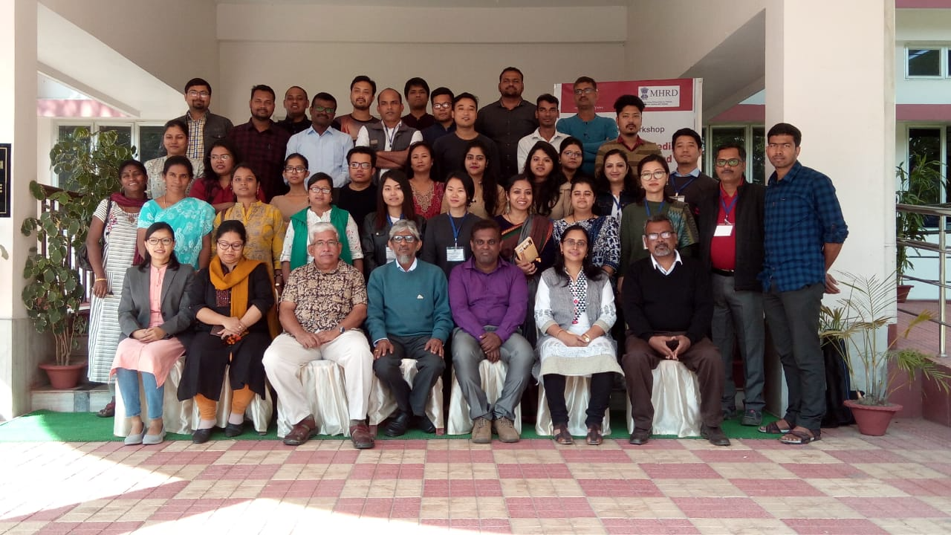
Day 1 (Feb 11, 2019, Monday)
Registration
The workshop began on Monday Feb 11, 2019, at 9.00AM with registration in which 43 participants consisting of faculty members, research scholars, and media professionals from both inside Tezpur University and outside the University from different parts of the country registered. A strict attendance list prepared and maintained throughout the week for each session separately. Only those who participated in all the sessions were finally given awarded certificate. (The schedule is attached separately)
Inaugural Session
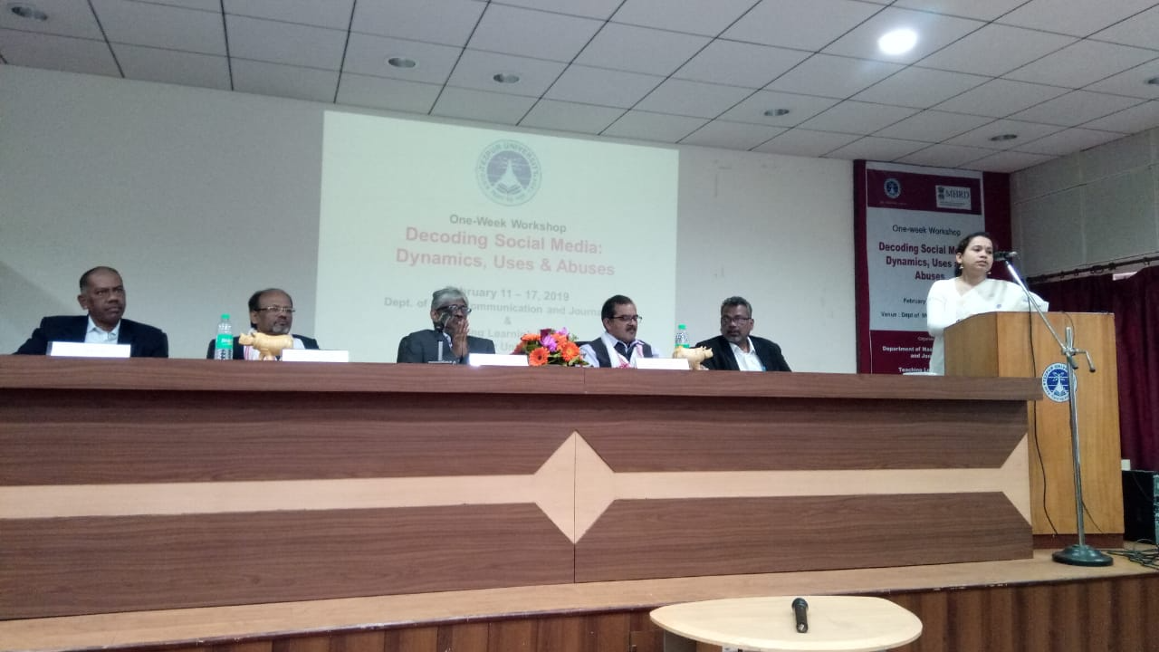
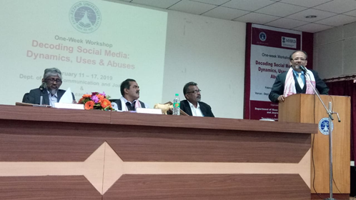
Well, we started off with the inaugural session with the felicitation and invitation of the guests. The HoD of Mass Communication and Journalism, Prof. Abhijit Bora, welcomed the resource persons and the participants and later the brief introduction of all the participants and a note about their expectations from this workshop. The Coordinator of the Workshop, Dr. P. Anbarassan gave an overview on the theme of the workshop. Assistant Professor, TLC TU, Dr. Swapnarani Bora talked about the collaboration between TLC and MCJ in conducting this workshop. The session was chaired by the Professor of Eminence, Prof. Sunil Behera. The resource persons provided a remark on the importance of social media. Professor Sisir Basu, provided us insights on the difference of the old and the new media and discussed key words like cultural screen and post truth. The Dean, School of Engineering TU, Professor S.K. Sinha made a note on content and computational trust. Ms. Pratisha Arora and Mr. Vikram Singh, from Social Media Matters gave us brief insights of their organisation and their organisational activities. Prof. Behera, provided a remark about this workshop, Assistant Professor, Dr. Anjuman Borah gave a vote of Thanks.

The first session
Professor S.K. Sinha talked about the trajectory of technology mediated communication from the agricultural age to the modern information age. He further stressed on the emergence of internet age being the outcome of the technologies of computation and communication. He talked extensively on the emergence of networks, types of servers, virtual hosting and elaborately explained how the networks graduated from slave master relations to client server relationships. He also mentioned about the differences between programming language and markup language.
Post lunch session
Social Media Matters, Delhi experts Ms Partishtah Arora and Mr Vikram Singh, introduced us to the basics of social media platforms and further elaborated on the dynamics of social networking.
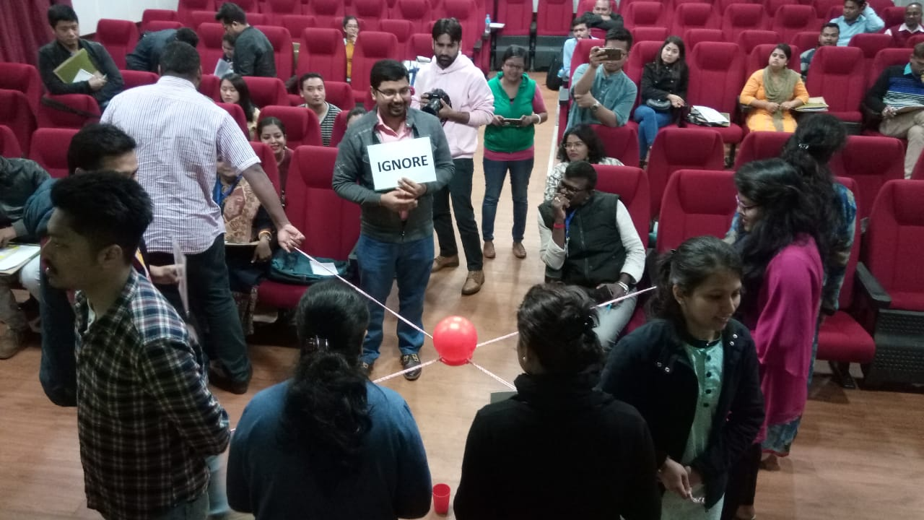
Day 2, (Feb 12, 2019, Tuesday)
First Session
The second day sessions started off with a practical session by Social Media Matters on the uses of privacy settings on Facebook and Twitter. The hands on training is focused on how to use and apply different privacy settings for a safer social networking.
Second Session
Prof. Sisir Basu from BHU deliberated on New Media and Marginalisation. He discussed about the political and sociological aspects of technological developments, he gave the example of the cold war era where the rivalries between two super powers had a direct bearing on a special focus on defence technology. Further he went on to elaborate the Foucaultlian concept of the ‘other’ which gave rise to the binary theory of the centre and the periphery that resulted into the marginalisation of the ‘other’ and extended this concept in the context of the fourth world.
The post lunch session
We had an extensive deliberation on the social media: critical readings of Key thinkers, by Prof. G. Ravindran from the University of Madras. His sessions were divided in two parts. In the first part of his lecture he extensively dealt on the western philosophers and communication thinkers. He made a clear distinction about them. He spoke extensively on Karl Marx’s concept of commodity, fetishism, alienation, Herbert Marcuse’s: one dimensional man, Horkheimer and Adorno on culture industry, Baudrillard’s hyperreality and implosion of media and sign value. Further he explained Kittler’s Discourse network stating that there is no software.
Prof Ravindran stressed the concept of ‘at a distance’ and spoke extensively on the gap between reality and hyperreality quoting Zizek. He, further elaborated on media archaeology, mediating reality and media implosion. He concluded by saying that we live in a highly indoctrinated society where the elementary truth is easily buried.
Day 3 (Feb 13, 2019, Wednesday)
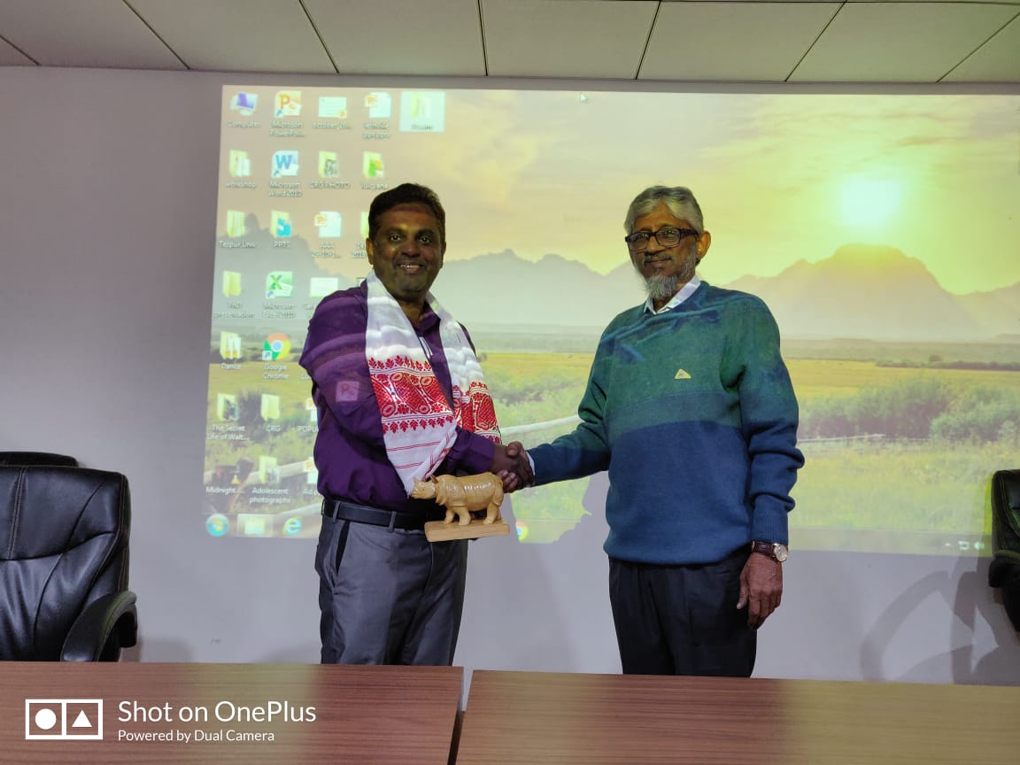
Morning Session
The third day, started off with the lecture by Dr. Shuaib Haneef, Pondicherry University on Social Media Spectacle. In his lecture, citing example from the book ‘Society of Spectacle’, he extensively talked about the twin factors associated with social media, commodification and alienation where he says that social media is a capitalistic instrument that creates a spectacle luring one out to be conscious about their appearance and hence commodification of the self. This instead leads to more alienation. He further talked about detourment, intertextuality and ended his lecture with a brief note on web 2.0
Post lunch session
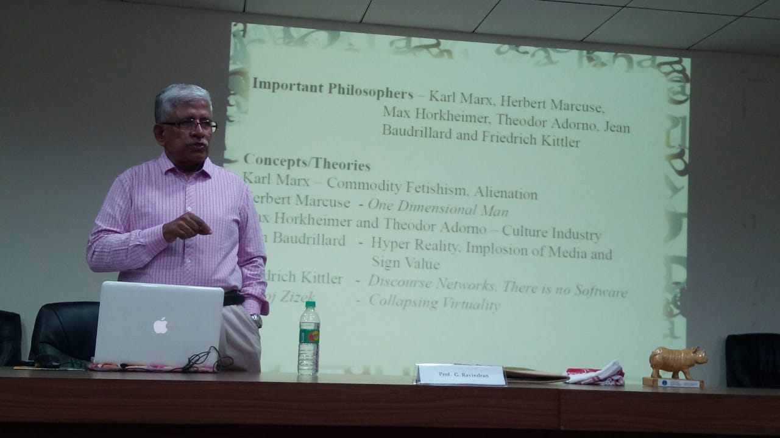
we had an intensive and extensive session on Understanding social media with Eastern Communication philosophies by Professor G. Ravindran. He started off referring to Buddha as the first communication philosopher through his modes of sermons. He spoke extensively on Appearance- as the non-intuitive knowledge, intuitive knowledge, duality and non-duality, Assured meaning and real meaning, error, truth, relative truth and the ultimate truth as the six philosophies while stressing on Buddhism principles. He went on to talk about Milas Ras Pa, the Tibetan philosopher explaining about the three levels of understanding reality. The first being driven by appearance and assumption terming as a false reality, the realisation of the false appearance lead to the second level and the third being the ultimate reality, attained so far by one and only, the Buddha. He also moved on to talk about Nagarjuna, a South Indian Philosopher where he explained the concepts of middle path (Madhyamika), emptiness (Sunyata), and absence of self being. He also talked about Jainism philosophy of communication referring to Ana-ken-da-vada (Relative pluralistic realities), Syad-vada (Conditional Predicated Reality), nya-vada (Partial reality), Pra-mana (Comprehensive logic) and Nya (Partial logic). He also brought out the relevance of the two praradox of Aristotle of form follows matter and that of Thirumoolar, Chapter 8 poem 2 concept of form defying matter.
In the next session, Prof. Ravindran talked about the Sociology of social media. He explained in detailed about the key terms and key thinkers; the fading of the social from Habermas, Simulacra, hyperreality and sinh from Baudrillard, Flows, network and interface from Lash, Territory as a map and map as territory by Borges, Co presence, cosociates and contemporaries by Shultz and Shenyang and scalable sociality by Miller. He further emphasized on Lash as a critic on Baudrillard by saying that the social cannot disappear and what changes is the interface and navigation of the social. Lash’s concepts of combinations, networks, flows and navigation are touched upon at a considerable depth.
Day 4, (Feb 14, 2019, Thursday)
First Session
Dr. Shuaib Haneef, Pondicherry University, enlightened us about algorithms. He stressed on how big corporates make use of algorithms for more capitalisation of products. His lecture centred around the social power of algorithms; surveillance of technology. He also touched upon gender and computational algorithms.
Second Session
The next session, Prof Abhijeet Bora, briefed us about the fake news across media. He provided examples of various types of news and how can they be termed as faked. He also touched upon the affects and the effects of fake news on media consumers as a whole. He stressed the importance and essence of validating information before circulation, especially for media professionals.
Post Lunch session
The second part of the day, we had hands on training by Dr Jai Kishan and Dr. Monjib Mochary, Assistant professors Assam Don Bosco University. Starting with the energisers, we learnt about the uses of Awesome Screenshot, Tin-eye on how to validate and authenticate whether a media image is faked or not.
Day 5, (Feb 15, 2019, Friday)
First Session
Former Pro VC of Assam University, Prof K.V Nagraj spoke at length on the subject of the importance of culture in communication by saying that the role of culture in communication cannot be underestimated. He started his lecture by saying that media are dream factories aimed for super profit and mass communication is but mind management for passive consumption. He went on to talk about the new media as a new form of massive self-communication of a passive narcissistic receiver. Prof. Nagraj further elaborated on the importance of reading a text in its context and of which he mentioned the types of contexts. Viz. the psychological context comprising of the individual psychology and institutional psychology; the cultural context, the historical context, the social context, the political concept specifying the copyright and copyleft, googlelology; and the commercial context.
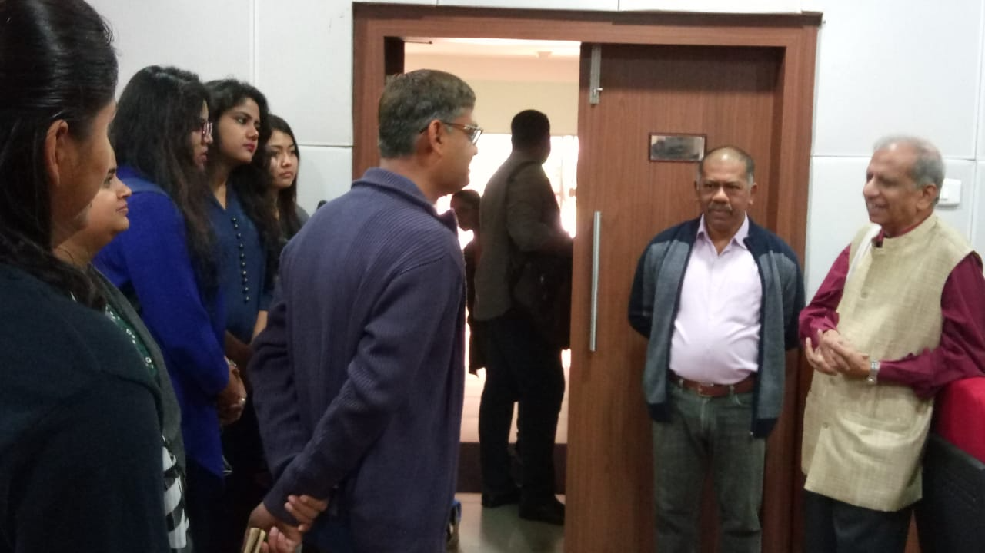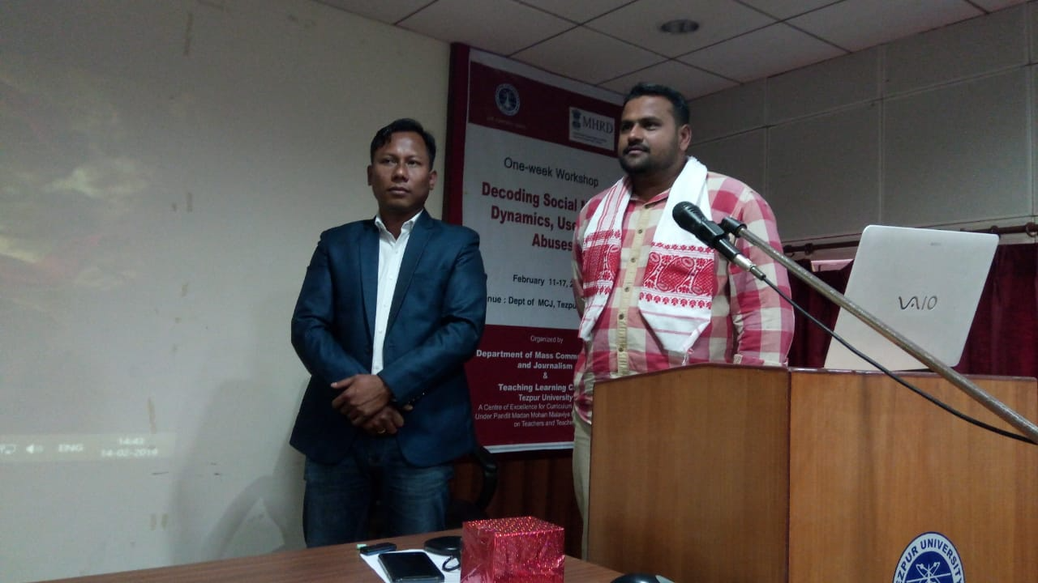

Second Session
The next session was a practical based self-learning session by Dr JaiKishan and Dr Mochahari, on how to identify, validate live images from the internet and to authenticate the originality of that media text using extensions like InVid,map checking, stalkscan, mapillary and google earth pro.
Post Lunch Session
Post lunch session we had Prof. T.T. Sreekumar from the EFL University, Hyderabad talking about privacy in the social media. He touched upon panopticon as disciplinary surveillance, the big brother surveillance while explaining about piracy. Touching upon the spectacle that goes beyond narcissism, Prof. Sreekumar talked about how this changed the way we look at privacy and how, we, as consumers actively participate in this integral part of surveillance. Whether good or bad, social media that feeds, breeds and reproduces more narcissism changed the way we look at ourselves. He also talked about the philosophical rupture caused by these new forms of media on the way how we understand ourselves and culture and how we view our privacy. He also brought about a paradox of the base and superstructure of Marx and Ambedkar.
Day 6, (Feb 16, 2019, Saturday)
First Session
Prof TT Sreekumar went on to explain a likely stage of new media redundancy or saturation point in the near future where nothing really matters. He further drew the examples from Eggers’ novel The Circle and The New Digital Age: Reshaping the Future of People, Nations and Business by Schmidt and Cohen predicting of what’s next. He also talked about global governance, democracy and empowerment. He ended his lecture with a note that media consumers have become subjects of global networks and social media are but ideological apparatus for interpolation of a new global economic order.
To close, from a wide array or social media spectrum of intellectual discourse to hands on experience it was indeed an enriched experience for all of us. We decoded social media, understood its dynamics, how to use it and where and how not to abuse and be abused.
Valedictory Session
Valedictory Session session was chaired by Prof. P.K Das, Dean, School of Humanities and Social Sciences, and also attended by Prof. Mrinmoy Kr. Sarma, Director, TLC, Prof. TT Sreekumar, Prof. K.V, Nagraj and Prof. A. Bora, HoD, MCJ.
Everyone gave a summing up speech on the significance of continuation of engaging with such an issue at different levels. The participants gave their comments and suggestions. The certificates were issued to the participants and the workshop ended with a vote of thanks by Dr. Uttam Kr Pegu.
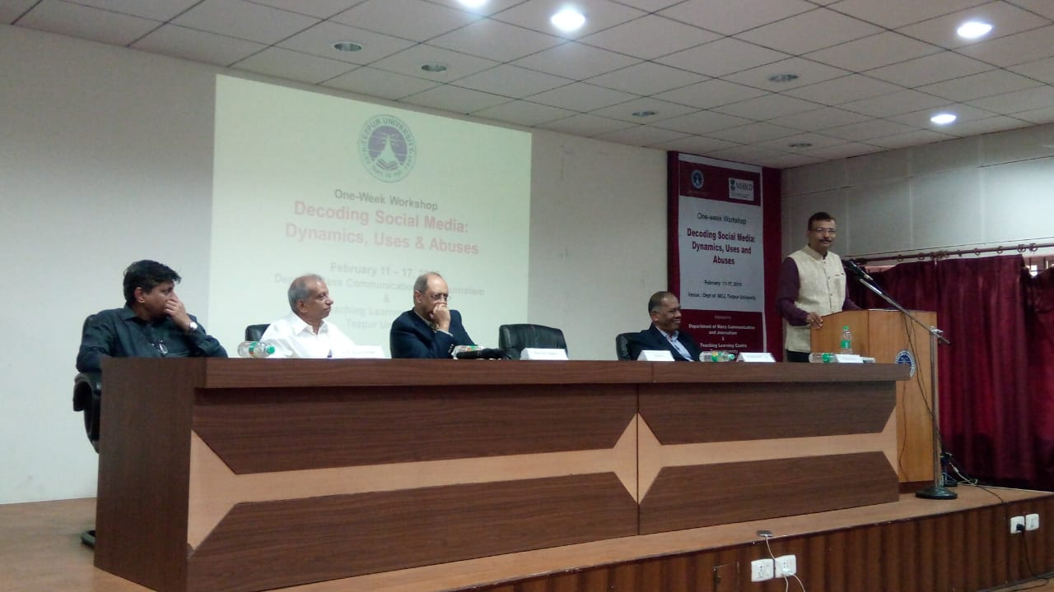
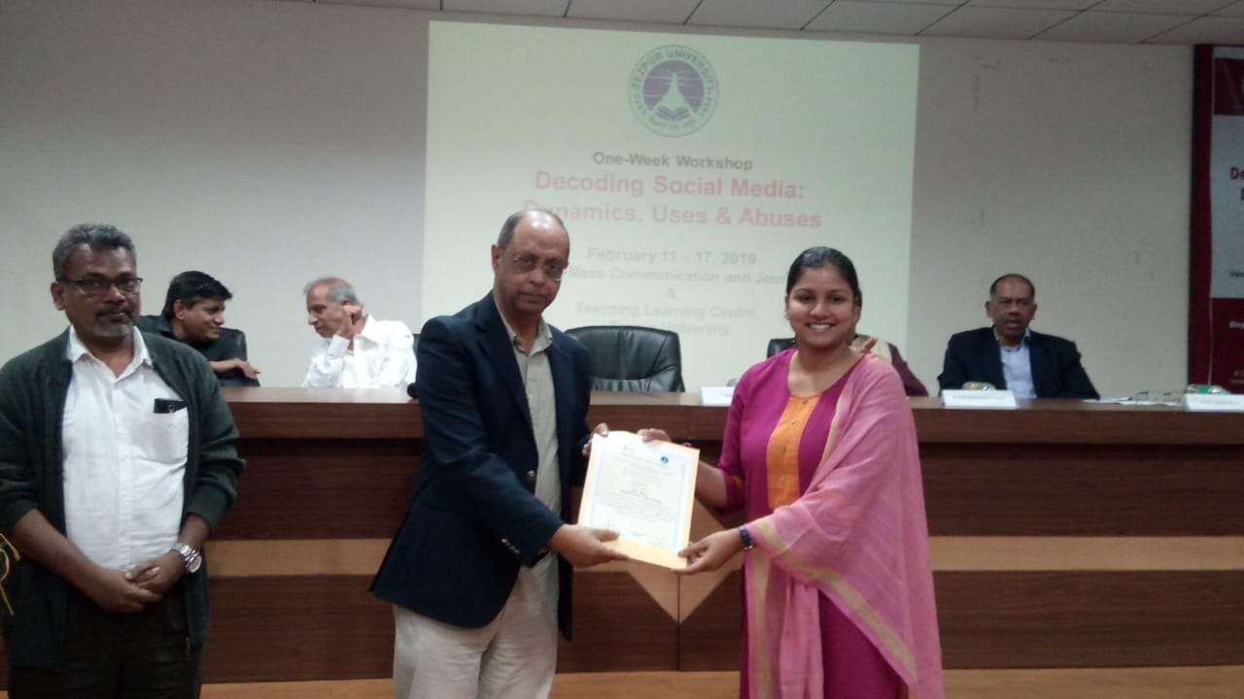

Day 7, (Feb 17, 2019, Sunday)
Participants went to visit Kaziranga and Tezpur town and since the valedictory was held before hand they were allowed to depart on the same day.

REPORT COMPILED BY
Dr P. Anbarasan
Associate Professor & Coordinator of the workshop

&
Dr Perosh Jimmy Daimari
Assistatn Professor
Co-Coordinator of the workshop

Dept of Mass Communication and Journalism
Tezpur University

