Week Long Short Term Training Programme on
Innovation and Rejuvenation of Teaching in Higher Education

A week long Short Term Training Programme on “Innovation and Rejuvenation of Teaching in Higher Education” was organized by IQAC, Silapathar College, Dhemaji from 28th December, 2018 – 3rd January,2019. The programme is sponsored by Pandit Madan Mohan Malaviya National Mission on Teachers and Training, MHRD, Govt. of India. There were 51 participants from different academic institutions of North East India. This workshop aimed to orient teachers towards recent developments in the fields of teaching practices and rejuvenate the teaching community for the challenges of 21st century teaching.
Day 1 (December 28, 2018)
Inaugural Ceremony:
The inaugural ceremony of the training programme started with introduction and felicitation of the guest conducted by Raju Pegu, coordinator of the workshop. The programme was inaugurated by Dr. Swapnarani Bora, Assistant Professor and Programme coordinator of Teaching Learning Centre, Tezpur University.
Dr. Swapanarani Bora formally welcomed all the participants from different academic institutions. She mentioned about the significance of the workshop and its aims about bringing together a core group of teachers from different academic institutions with a significant participation from our own state. She also stated that the programme aimed to orient the teachers towards recent developments in the fields of teaching practices and rejuvenate the teaching community for the challenges of 21st century teaching. She wished for the success of the workshop and inspired and motivated everyone to actively participate in the workshop to get benefitted. The inaugural ceremony of the workshop concluded with vote of thanks extended by Raju Pegu.

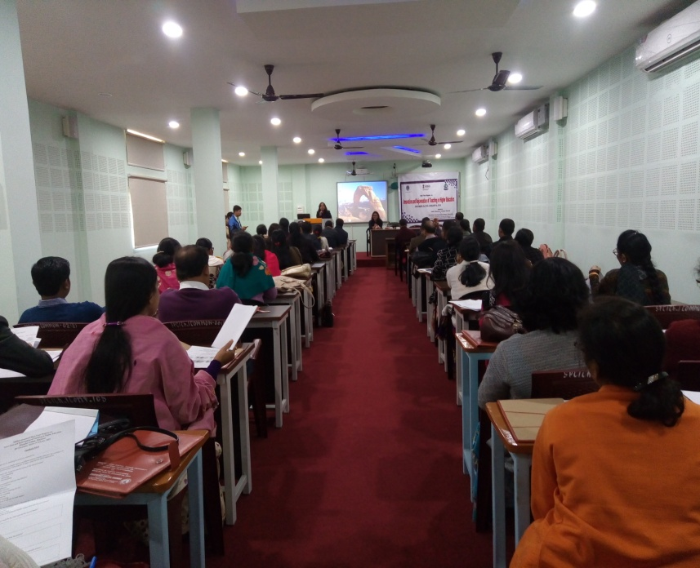
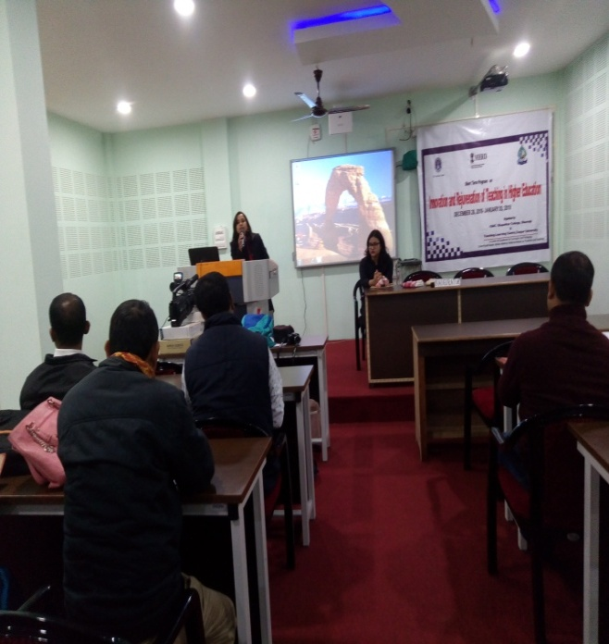
The first two sessions of the workshop was taken by Prof. Neeta Kalita Barua, Department of Education, Dibrugarh University from 11.15 am to 12.45 and 1.45 to 3.15. The speaker delivered her speech on “Quality of an Effective Teacher Constructivism in Teaching” mentioning about the Challenge for faculty to be effective in teaching and to make teaching and learning relevant. The speaker also pointed the purposes of self-evaluation, using variety in speech, gestures, and facial expressions, moving around the room, maintaining eye contact, encouraging participation, soliciting input from students, maintaining a brisk lesson pace, what is teaching Pedagogy, factors that determine the pedagogy, traditional class room and constructivism in class room etc.
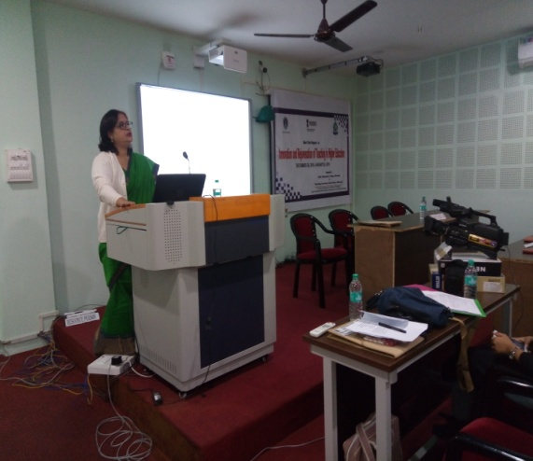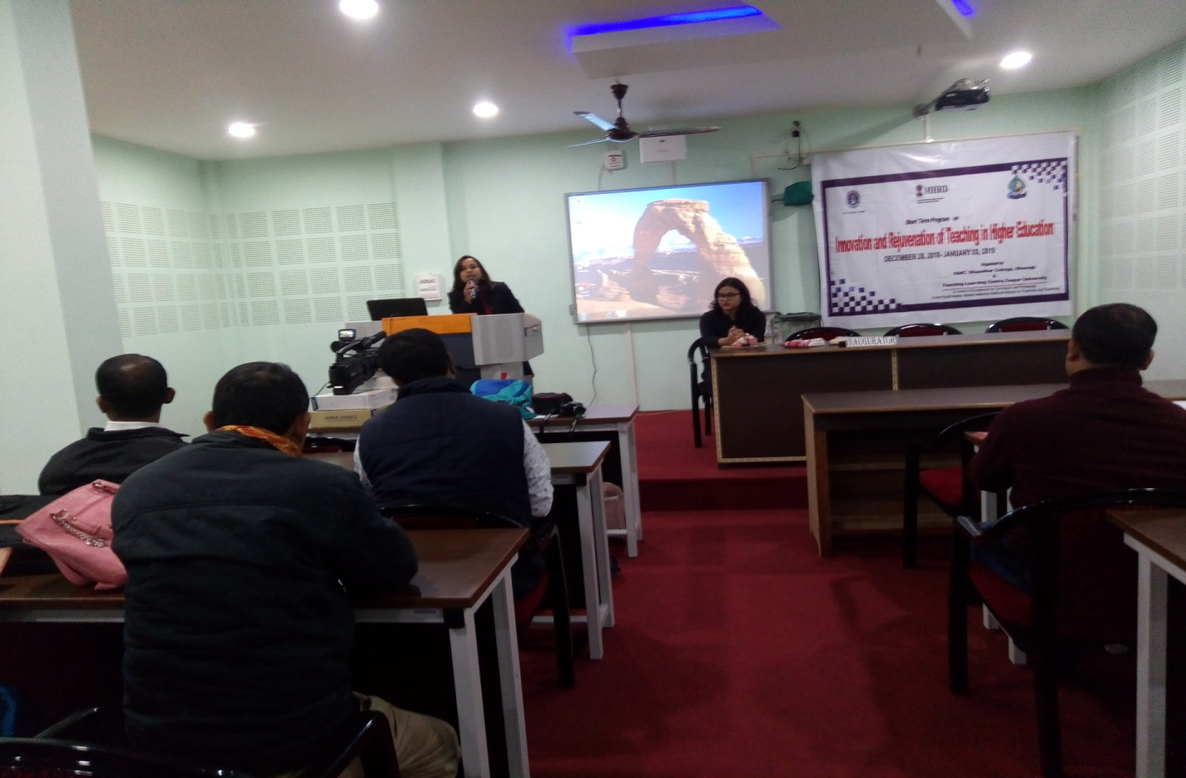
The last session of day 1 was on Group activity taken by Dr. Swapna Rani Borah, Assistant Professor, Department of Assamese and Coordinator of Teaching Learning Centre, Tezpur University. She informed the participants about uploading of videos in You tube and contribution to e-resource link as well how to present audio- visual power point presentation in the class room.
Day 2 (December 29, 2018)
The first session of the pre-lunch was conducted by Prof. Surajit Barkataky, Chairperson of CCS, Dibrugarh University on “ICT based Teaching Learning” from 9.30- 11.00 am. In this session, the speaker discussed elaborately about the role of tools in teaching learning, integration of ICT to enhance teaching learning and web 2.0 supported pedagogies and how to use ICT in class room management for an effective teaching.
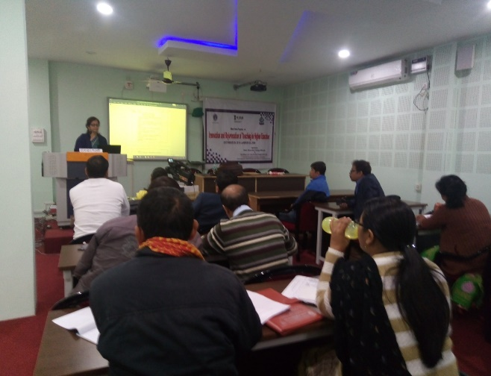
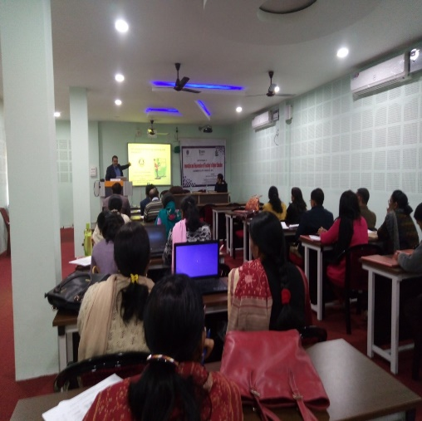

The second session of the pre-lunch was taken by Dr Shrutidhara Mahanta, Assistant Professor, Department of Education, DODL, Dibrugarh University on “ICT based Teaching Learning & Evaluation”. She informed the participants how ICT helped to create teaching materials, how to use online resources through ICT for class room management.
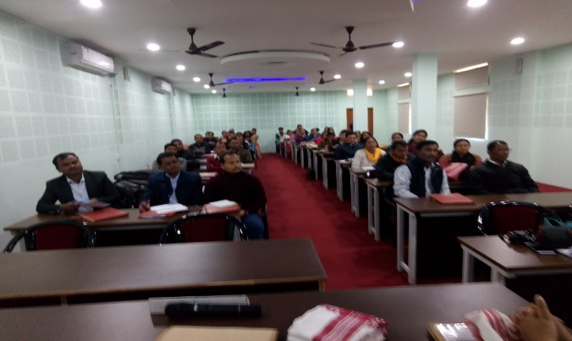
The post lunch was taken by Prof. Mukut Hazarika, Dean School of Education, Dibrugarh University on “Evaluation of Students’ Achievement”. The speaker mentioned about the methods of question paper setting, evaluation of test paper, characteristics of a good test, how to write a multiple choice question paper, to check the level of understanding of students, assessment for identifying the weak areas of students and adopt suitable remediation measures for the same. He also conducted activities on principles of test construction.
Day 3 (December 30, 2018)
First two sessions of day 3 were conducted by Dr. Pranjal Buragohain, Assistant Professor, Department of Education, Dibrugarh University on the topic “Learner Centric Approach of Teaching” and “Effective Classroom Management”. He discussed in length the psychology of adolescence and the challenges faced by adolescence. He also pointed the importance and certain strategies that can be used by the teacher for an effective class.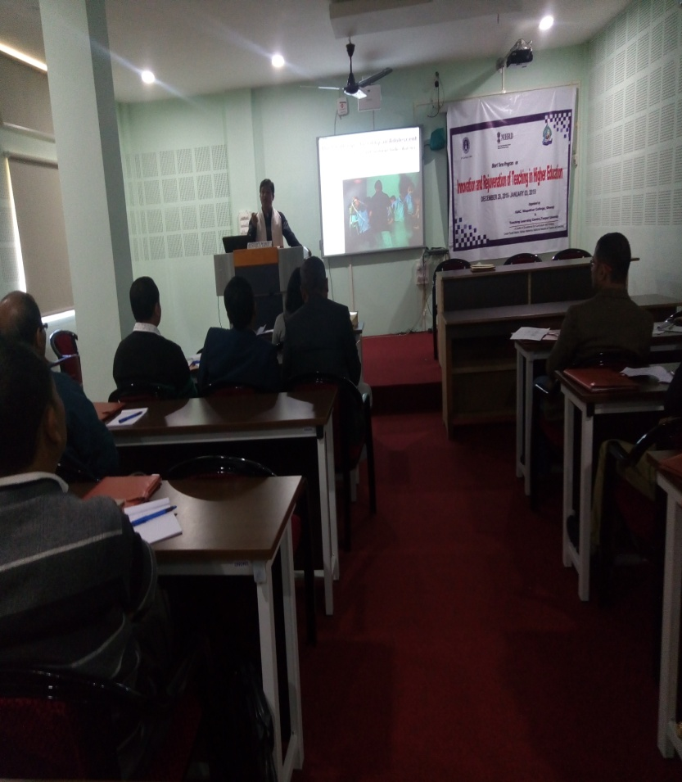 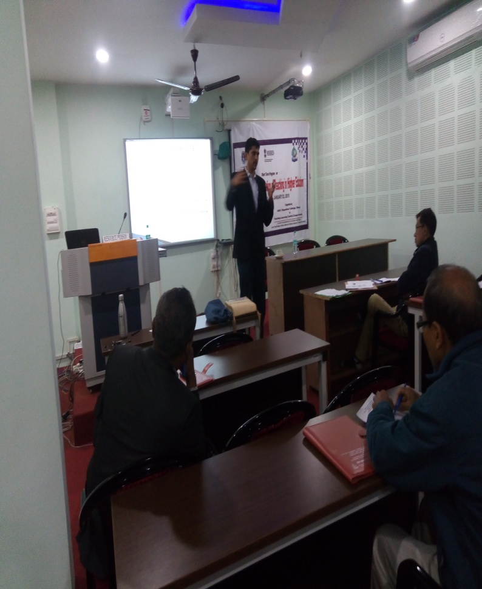
The post lunch session of day 3 was taken by Dr. Amar Upayadhya, Assistant Professor, Department of Education, Dibrugarh University on “Innovative Teaching Practice I and Innovative Teaching Practice II”. The speaker explained about innovation through Play, Role-Play and problems in Higher Education, innovative teaching and learning Practices Using Student Partnerships, teaching and learning innovations Using Modern Technologies, innovation through Case-based teaching and learning, innovation through Authentic Learning Environments, Experiences and Field Work, Innovative Teaching and Learning practices using E-learning, digitization knowledge of India, blended learning and collaborative method of learning.

Day 4 (December 31, 2018)
In the pre-lunch sessions of day 4 Dr. Hiranya Chalia, Principal, Kaliabor College, delivered his speech on “Empowering Teachers III and Student Support”. The speaker explained in details how a teachers can support students in building a better person- a real resource, Teaching about specific issue, Particular skill, growth by sharing resources & Networks, focusing on total development, Encourage students for National Integration- celebrating, awareness, motivation, Campaign on Anti-ragging, Anti-drug, witch hunting, Cyber crimes etc. He also gave overview on critical thinking, scientific temper, the six pillars of scientific temper, scientific literacy, interdisciplinary collaboration etc.
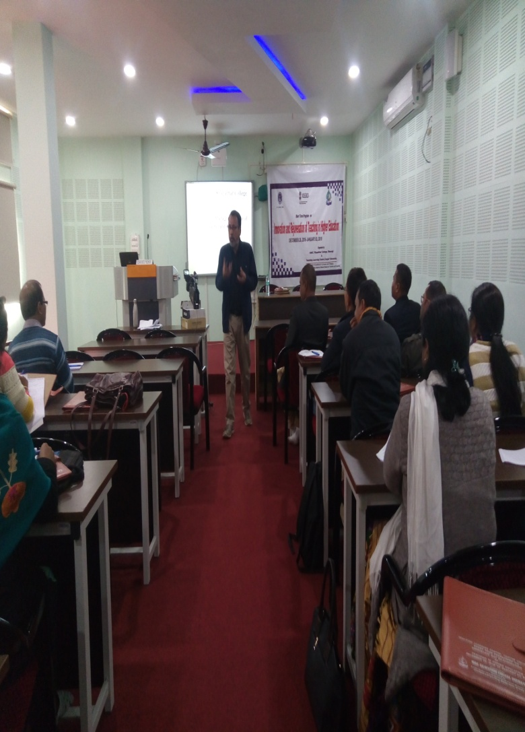
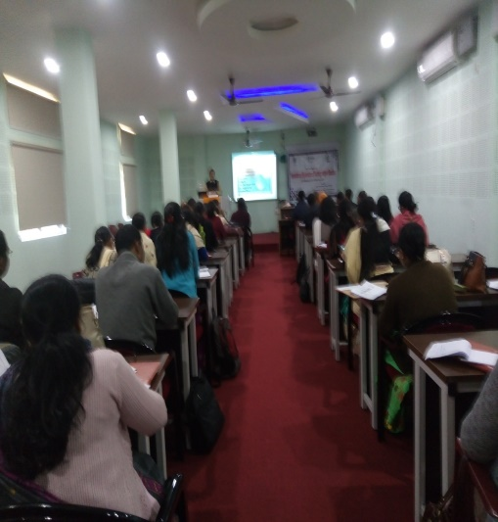

The third session of the day was conducted by Prof. Sarat Ch. Kakati, Dibrugarh University on “Role of Teachers in Institution Building”. He said that teachers play a very pivotal role in achieving the institutional goals and objectives, community building and cohesion. The teacher can also play an active role in the development of institutional perspective plans.
The last session of day 4 was on activity conducted by Dr. Swana Rani Borah. The session involved discussions and exercise of uploading videos in you tube as well as how to make audio- visual power point presentation.
Day 5 January 02, 2019
The fifth Day of First two sessions were taken by Dr. Paresh Baruah, Rtd. Principal, Dibru College, Dibrugarh on “Empowering Teachers I and Empowering Teachers II”. In “Empowering Teachers’ I” he highlighted the importance of gender equality, women’s empowerment, economic, social and cultural constraints, stereotypes sex hampers quality etc. In “Empowering Teachers’ II” he elaborately described the problematic definition of research in undergraduate levels of student participation, contexts for developing undergraduate activity, dimensions for framing undergraduate research contexts and mentoring undergraduate research.
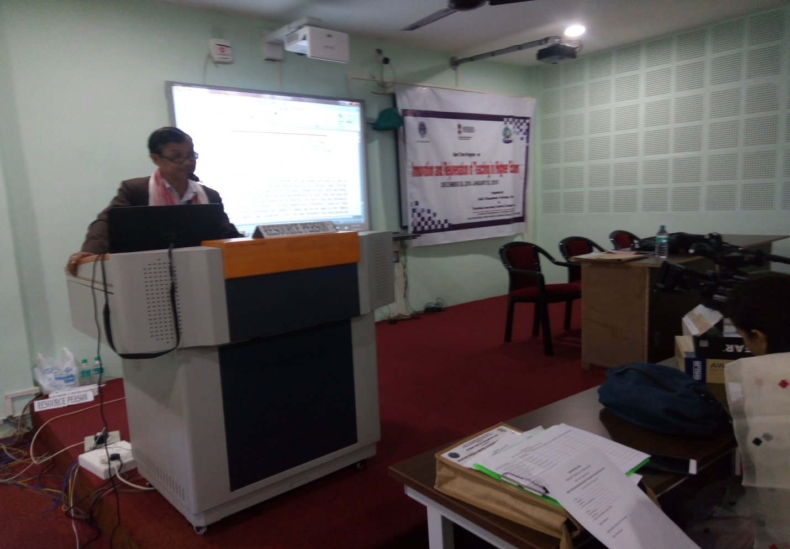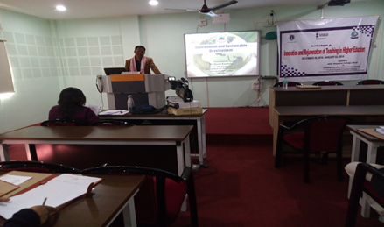
The post lunch session of the day was taken by Dr. Devid Kardong, Associate Professor, Department of Life Science, Dibrugarh University on “Environment and Sustainable Development”. The speaker highlighted the importance of organizing awareness programme among the students and society to control the Global Warming. He also explained about the change of climate, how to control population, planting trees, ground water reservation and recycling of non-degradable waste.
The last session of day 5 was on group activity taken by Dr. Swapana Rani Borah, Assistant Professor, Department of Assamese, Teaching Learning Centre,Tezpur University. In this session participants presented their videos as well audio- visual power point presented.
Day 6 (January 3, 2019)
In the first two sessions of the last day of the workshop was taken by Professor Kalyan Bhuyan, Department of Physics, Dibrugarh University on “Best Practices in Higher Education and Teacher and Society”. He said that the best practices benchmarking approach to quality enhancement can be implemented by adopting five strategies: The identification basically depends on many parameters such as institutional goals, pedagogic requirements, global concerns, local contexts, nature of learners, competences of the staff, infrastructure facilities and governance requirements. He also mentioned that the teacher’s place in society is of vital importance, he acts as the point for the transmission of intellectual tradition and technical skill from generation to generation and helps to keep the lamp of civilization burning.
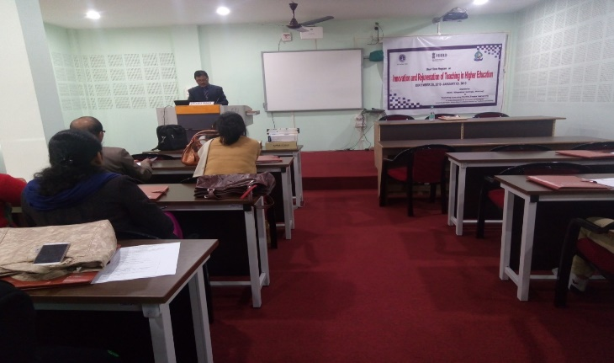
Valedictory session was held after the post lunch session. The session was chaired by Dr. Lakhinath Pegu, Principal, Silapathar College. Professor Mrinmoy Kumar Sarma, Director, Teaching Learning Centre, Tezpur University graced the occasion. Dr. L.N Pegu, Principal Silapathar College thanked Teaching Learning Centre, Tezpur University for giving opportunity to organize the programme at Silapathar College. Professor Mrinmoy Kumar Sarma delivered a thought provoking speech by encouraging the participants to do their best to improve their teaching and thereby serve the cause of higher education and nation. He told the participants to be good motivator and facilitator of the students. The director ended his speech with a quotation by Socrates “the greatest wisdom is to know that you know nothing” A few Participants gave their feedback regarding the sessions of workshop. Certificates of completion were given to all the participants at the end. The valedictory session concluded with a vote of thanks offered by Raju Pegu, Assistant Professor & IQAC Coordinator.
