TEACHING LEARNING CENTRE, TEZPUR UNIVERSITY
Short Term Programme on
INNOVATION AND REJUVENATION OF TEACHING IN HIGHER EDUCATION
Organized by
IQAC, NORTH LAKHIMPUR COLLEGE (Autonomous)
18th to 23rd February, 2019
Sponsored by
Pandit Madan Mohan Malaviya National Mission on Teachers and Teaching, MHRD,
Govt. of India.

A Report on the completition of the Programme

18th February, 2019
A week long Short Term Programme on “Innovation and rejuvenation of Teaching in Higher Education” started on 18th February, 2019. The registration started at 8:30 a.m. and all together 40 number of participants from various colleges in Assam registered for the programme. The Inaugural session was held at 9:30 a.m. in the Digital Class Room, and was anchored by the host Coordinator Dr. Binda Sah. After the felicitation of the President, Dr. Biman Ch. Chetia, the inaugurator, Dr. Hemanta Kr. Boruah, and the home coordinator from T.L.C., Tezpur University, Dr. Swapnarani Bora, the anchor handed the agenda over to the President of the session, Dr. Biman Ch. Chetia to carry on the programme.
In his welcome speech the Principal of the college and also the President of the inaugural session focused on teaching as a challenging job and emphasized on the necessity of the use of ICT in Pedagogy and Innovation in teaching technique as well.
The President requested the inaugurator Dr. Hemanta Kr. Boruah to inaugurate the programme with an inspiring speech. In his short speech Dr. Hemanta Kr. Boruah emphasized that the traditional teaching needs to be renovated to keep pace with changing circumstances. This was followed by the orientation of the programme by Dr. Swapnarani Bora who acquainted the participants with the true nature of the programme. After giving a brief idea about the course, she expressed that apart from API, the course is needed to cope up with the 21st Century teaching. The inaugural session concluded with a brief introduction of the participants.
The first technical sessional started at 11:15 a.m. by Dr. Swarnalata Das who talked on the qualities of an effective teacher. The session was highly interactive as the participants expressed the opinions based on their experience.
The second session was an Activity by Dr. Swapnarani Bora which started at 1:45 p.m. It was on screen casting, google classroom and e-resource repository.
The last session of the day was conducted by Dr. Swarnalata Das, at 3: 30 p.m. who discussed with the participants on the role of teacher in the society. She also covered issues related to students, social structure and the role of education sector.
19th February, 2019
For the second day of the programme two resource persons were invited Dr. Neeta Kalita Boruah from Dibrugarh University and Dr. Sarat Saharia from Tezpur University, Dr. Neeta Kalita Boruah took the first two sessions on constructivism and teaching pedagogy and learner-centric approaches respectively. In the first session she acquainted the participants with the theory of constructivism and laid emphasis on its application in Higher Education. In the second session she discussed with the participants the importance of learner centre approach in our contemporary context
The third and fourth session was conducted by Dr. Sarat Saharia on the topics “ICT based Teaching and Learning” and “ICT based Teaching, Learning and Evaluation” respectively. In the first session he discussed the importance of ICT in teaching, education technology and web 2.0 support technologies. In the second session he acquainted the participants with Google Classroom, Google Form and Cam Studio.
20th February, 2019
Session 1 (9:30 a.m.): This session was conducted by Mr. Sonit Jyoti Saikia, a theatre activist who took up the issue of drama as innovative pedagogy. He practised with the participants how teaching can be made effective by involving drama or dramatic action.
The second and the third session was conducted by Dr. Manabendra Mandal from Tezpur University who discussed the issue fo “Role of Teachers in Institution Building” and “Student Support “respectively. He interacted with the participants on various issues related to the topics and also shared his own experience.
The fourth session was an activity session by Dr. Swapnarani Bora who reviewed the screen casting videos submitted by the participants.
21st February, 2019
To conduct the fourth day of the programme we had invited Dr. Manashree Gogoi and Dr. Mukut Hazarika from Dibrugarh University. Dr. Manashee Gogoi took the first and fourth session on the topics “Blended Larning and Flipped Classroom” and “Test Construction” respectively. She focused on the importance of shift from traditional teaching to online learning and their blending as well. She also gave an activity on test construction by evaluating the previous year question papers.
The second and the third session was conducted by Dr. Mukut Hazarika who talked on “Collaboration and cooperative learning” and “Assessment of Learning and Question Paper Setting”. He made the third session activity based in order to show the process of paper setting.
22nd February, 2019
The first two sessions on 22nd February, 2019 were conducted by Dr. Daisy Bora from Dibrugarh University on the topic “Empowering Teachers-I” and “Empowering Teachers-II” respectively. In the first session she discussed the issues of Students Research and discrimination of research along with different forms of teacher empowerment. In the second session she took up the issues of inclusivity in classroom and understanding gender, and gender sensitivity.
The third and fourth session was conducted by Dr. Pranjal Burahgohain on the topics of “effective Classroom Management” and “Empowering Teachers-III” respectively. He made his both sessions interactive and took up the issues of critical thinking, scientific temper and the teaching that strengthens executive function network.
23rd February, 2019
The first session was Activity by Dr. Swapnarani Bora who reviewed the screen casting videos submitted by the participants, and also talked on the uses of e-resources.
The second session was taken by Dr. R.R.Hoque from Tezpur University who first acquainted the participants with the issues of environment and sustainability and then carried on a discussion with the participants on healthy environment.
The third session was conducted by Dr. Biren Das, the Registrar of Tezpur University who took up the topic of “Best Practices in Higher Education”. The session was interactive as Dr. Das, after speaking on the concept, asked the participants to share some good practices in their respective colleges.
The last session was Valedictory which was chaired by Dr. Biman Chandra Chetia, the Pricipal of North Lakhimpur College and graced by Dr. Mrinmoy Kr. Sarma, Director of T.L.C., Tezpur University, and Dr. Biren Das, Registrar of Tezpur University.
Dr. Biman Chandra Chetia in his valedictory speech laid important on the relevance of such programmes considering the challenging context of our time. This was followed by opinion of the participants. A large number of participants shared their opinions and expressed desires to attend another such programs by TLC, Tezpur University.
Dr. Biren Das in his speech assured that such programs will definitely be conducted in future. He emphasized on the seriousness of the programmes conducted by TLC. He also requested the participants to join Induction Programme conducted by TLC. at Tezpur University.
The speech of Dr. Das was followed by the distribution of certificates to the participants by Dr. Mrinmoy Kr. Sarma, Dr. Biren Das and Dr. Biman Ch. Chetia. This was followed by the valedictory speech by the Director of TLC., Tezpur University, Dr. Mrinmoy Kr. Sarma. Dr. Sarma congratulated all the participants for successfully completing the programme. He expressed his joy over the 100% attendance of the participants and hoped that the participants had come not only for API, but to be rejuvenated. He shared his experience of teaching and acquainted the participants with the challenges of teaching in future considering the dominance of technology and innovation in contemporary context.
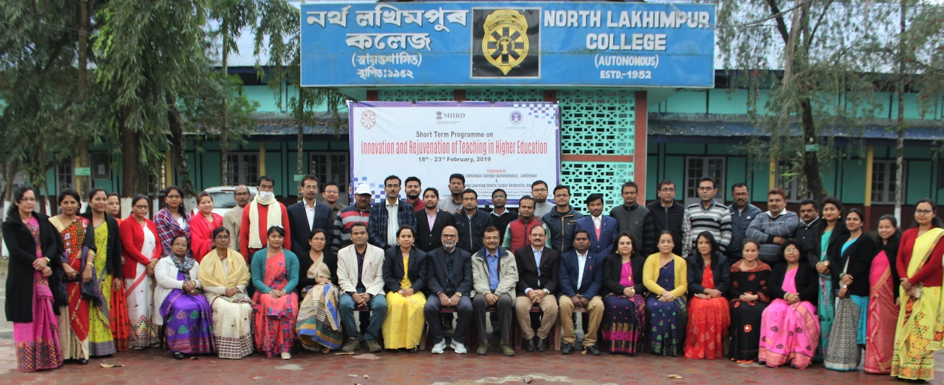
At last, all the participants offered a token of respect and affection to Dr. Swapnarani Bora, the coordinator of the program from T.L.C., Tezpur University, and this was followed by a vote of thank by Dr. Binda Sah, the coordinator of the programme from North Lakhimpur College after which the chairperson, Dr. Biman Ch. Chetia officially declared the end of the programme.

