Report on
Two-Day Workshop on ICT in Management of Education
In collaboration with
Nowgong College, Nagaon
Date: 22/05/19 and 30/05/19
Venue: Nowgong College, Nagaon, Assam

Teaching Learning Centre, Tezpur University in collaboration with Nowgong College, Nagaon organized a Two-Day Workshop on ICT in Management of Education on May 22 2019 and May 30, 2019. This was part of a series of TLC, TU program dedicated to train the teachers in using ICT with available devices for educational purposes. The program focused on using Screencasting as tool for effective teaching. On day one, trainees were given hands on training on using Screencasting software. Then they were assigned to create one video module using Screencasting method. Trainees got one week to practice at home during which period TLC staffs assisted them over phone and other medium whenever required. On the second day of the program, the trainees presented the Screencasting video which was then evaluated by TLC representative and other co-participants. Around 65 teachers attended the program from Nowgong College and other nearby colleges. The program was coordinated by Ikbal Ahmed and Dr. Swapnarani Bora from TLC,TU and from Nowgong College, Dr. Banashree Saikia, Dr. Krishna Kanta Medhi, and Dr. Cintamoni Sarma were local coordinators.
This program was funded by TLC,TU under PMMMNMTT Scheme.
Day-1
The program was started with a short inaugural speech by Dr. Sarat Borkataki, Principal, Nowgong College who emphasized on the significance of such training, as ICT has become an integral part of higher education. He expressed his gratitude to TLC for supporting college’s’ proposal to conduct the program.
The first technical session was conducted by Prof. Nityananda Sarma, Professor, Department of Computer Science and Engineering, Tezpur University. His topic was “Use of ICT in Managing Different Components of Teaching Learning”. In this session, Prof. Sarma reflected on the changing paradigm of teaching and learning in today’s world. He said that walking into a classroom today is very different from walking into a classroom ten years ago. The advances in educational technology have created drastic changes in the teaching-learning process. Students today have easy access to information and thereby it is necessary to guide them in choosing and using this information in a proper way.
He defined ICT as the technology that is used to create, convey, manipulate and store data by electronic means. He said that ICT can help in teaching and learning in various ways. It allows students to have more control over their own learning. It makes them actively engage in the teaching learning process. It helps the teachers to guide more and teach less and to identify the ‘at risk’ students. He showed with a chart how the use of online delivery has increased in today’s education system. Unlike the traditional system where the content is delivered face to face, in Blended Education both face to face delivery and online content is used, whereas in online courses like MOOCS almost all the content is delivered online.
Use of ICT has changed the role of both teachers and learners. From a transmitter of knowledge, the teacher has changed into a guide and a facilitator of knowledge, whereas the learner has changed from passive to an active learner and from a dependent learner to an autonomous one. They become the producer of knowledge and have learnt to think, create, communicate and collaborate. Prof. Sarma informed the class about different ICT tools that can be used for effective classroom management. He also emphasized on the significance of Screencasting as tool for education.
The second session was conducted by Prof. Debajit Hazarika, Department of Mathematical Science, Tezpur University on “Role of Moodle in Higher Education.” Prof. Hazarika said that the use of ICT in each and every sphere of our life has changed our life style. Therefore, to keep in the pace of time, one must think to bring the learning experience close to the learners while they are logged in to the internet. The Universal knowledge accessibility and explosion of knowledge had made the learners informative about many things. At the same time teachers are responsible for various duties along with teaching. He referred that the introduction of ICT tools in education like WordPress, EduCreation, GoogleDocs, GoogleClassroom, MOODLE etc are gearing the teaching learning to a new dimension. Among them MOODLE is an open source learning management system, distributed under general Public licence. The speaker then provided the general history of MOODLE, its contribution in creating effective online learning environment and the pedagogic power of MOODLE. Thereafter, the activities of MOODLE have been shown in detailed, from creating a course material to enrolling students.
The third session was carried out by Dr. Swapna Bora, Assistant Professor, TLC, TU. Dr. Bora gave hands on training on how to use Google Classroom for classroom management. She demonstrated and guided the participants through every steps of Google Classroom. From creating a classroom, joining classroom, how students can be added or removed, how assignments are created and shared, and how feedback is given in classroom. She also answered different quaries related google classroom.
The fourth session was conducted on creating video modules using Screencasting tools by Ikbal Ahmed, Assistant Professor, TLC, TU. Mr. Ahmed discussed briefly about the history and use of Screencasting, it implications for innovative teaching practices like Blended Learning and Flipped Classroom. After surveying the competency of participants in using computer, Mr. Ahmed demonstrated Screencasting method starting from installation to use of Screencasting software. He mentioned about several software but for demonstrative purpose used “Screencast-O-matic’. The participants were asked to practice the entire process of Screencasting in the classroom. Finally, participants were assigned to create one short video module on topic of their choice using Screencasting tool. The participants were given time until 30th of May 2019 which was the second day of the workshop.
Day-2
Day 2 was designated for presentation and evaluation of the video modules. A majority of participants were able create short video modules using Screencasting tools. TLC representatives Dr. Swapnarani Bora and Ikbal Ahmed evaluated the presented video. Co-participants also suggested different corrections to improve the videos.
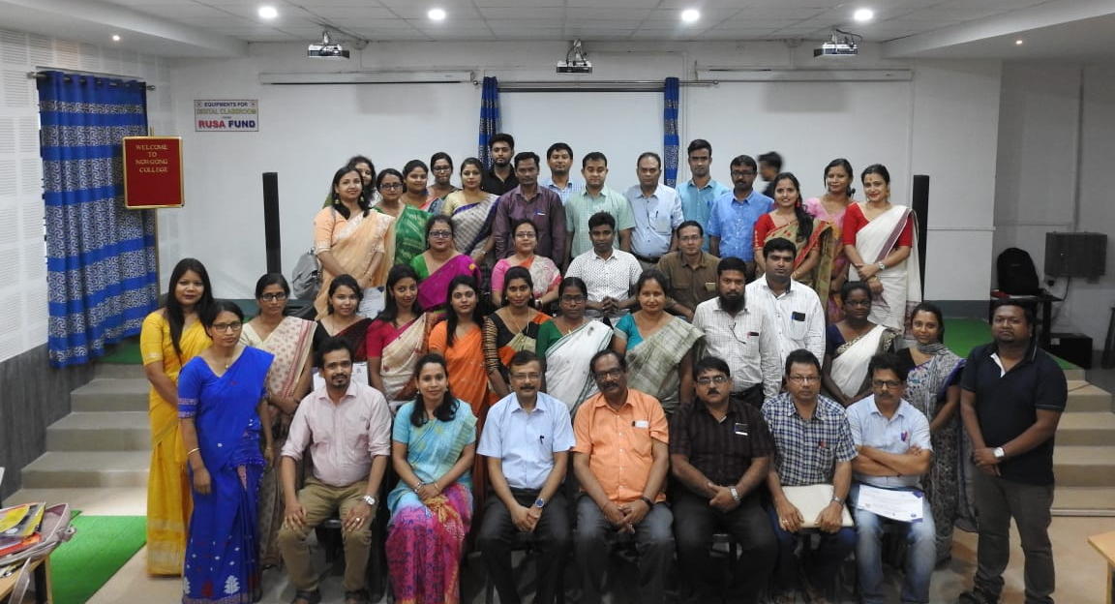
In the post lunch session, there was a short valedictory ceremony. Prof. M. K. Sarma, Director, TLC delivered a valedictory speech. Prof. Sarma described briefly about the purpose of the ICT workshop and implications for ICT in education. He lauded the participants who were able to create short video modules after this training. Prof. Sarma thanked Nowgong College for supporting the endeavor of TLC. Dr. Borkataki, the Principal, Nowgong College, has been instrumental in motivating teachers from nearby colleges to join this training. The program ends after distribution of certificates to the successful participants.

The participants of the workshop along with Principal, Nowgong College, Director, TLC and Coordinators from TLC and Nowgong College.

