Title of the paper to be presented in CMDAYS17

Authors’ Names
Affiliation

Corresponding author’s E-mail:

Abstract: One can use this template. The abstract should be limited to 250 words. It should follow the sequence: title, author’s name, affiliation/address, main abstract, keywords, and references. The title of the abstract should be bold face and in upper case letters in Times New Roman 14pt. The author(s) name(s) in 13pt. and affiliation(s) in 12pt., latter being in italics. The e-mail address of the corresponding/presenting author should be mentioned below the line for affiliation. Any schematic representation/diagram or table may be included (limited to one only) which can be placed between the keywords and references sub-headings. The name of the presenting author should be underlined. Please consider single line spacing in the text.
Key words: Pqrst; Uvwxyz; Spqrt; Ijklm

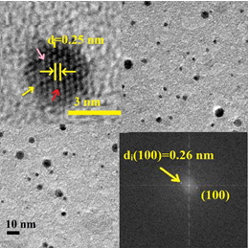

Figure: TEM image of an unknown specimen. Insets showing lattice fringe pattern and FFT.

References

[1] A. Bcde, F.Ghijk, L.Mnopqr, J. Known to me, Volume (Year) page.
[2] Hand Book of Abc and Cdefgh (eds.) K. Lmnop and T. Uvwx, XYZ Publications, n^{th} edition (Year), City.

