Paper for SMETB 2017 A4 Page Size
First Author¹, Second Author², Third Author³
¹First Author Affiliation
¹first.author@author.ac.in
²Second Author Affiliation
²second.author@author.ac.in
³Third Author Affiliation
³third.author@author.org.in

Abstract— This document gives formatting instructions to contributory authors for submitting paper. The authors must follow the instructions given in the document for the papers to be published in the proceedings of SMETB 2017. Paper should be submitted in .doc or .docx format with maximum number of six pages.

Keywords— Include at least 5 keywords or phrases
- Introduction
This document is an instruction template. Soft copy can be downloaded from the conference link available in the webpage of department of Mechanical Engineering, Tezpur University. For any queries, please contact as indicated on the conference link. Information about final paper submission will also be available from the conference link.
- Page Layout
An easy way to comply with the conference paper formatting requirements is to use this document as a template and simply type your text into it.
- Page Layout
Your paper must use a page size corresponding to A4 which is 210mm (8.27") wide and 297mm (11.69") long. The margins must be set as follows:
- Top = 25.52mm (1.00")
- Bottom = 38.31mm (1.50")
- Left = 25.52mm (1.00")
- Right = 14.32mm (0.56")
Your paper must be in two column format with a space of 4.22mm (0.17") between columns.
- Page Style
All paragraphs must be indented. All paragraphs must be justified, i.e. both left-justified and right-justified.
- Text Font of Entire Document
The entire document should be in Times New Roman font. Recommended font sizes are shown in Table 1.

- Title and Author Details
Title must be in 20 pt Regular font. Author name must be in 11 pt Regular font. Author affiliation must be in 10 pt Italic. Email address must be in 9 pt Courier Regular font.

TABLE I
Font Sizes for Papers
Font Size | Appearance (in Times New Roman)
Font Size | Regular | Bold | Italic
8 |  | table caption (in Caps),  figure caption,  reference item | reference item (partial)
9 | author email address (in Courier),  cell in a table | abstract body | abstract heading (also in Bold)
10 | Body Text | level-1 heading (in Small Caps),  paragraph | level-2 heading,  level-3 heading,  author affiliation
11 | author name
24 | title

Title and author details must be in single-column format and must be centered.
Every word in a title must be capitalized except for short minor words such as “a”, “an”, “and”, “as”, “at”, “by”, “for”, “from”, “if”, “in”, “into”, “on”, “or”, “of”, “the”, “to”, “with”.
Author details must not show any professional title (e.g. Managing Director), any academic title (e.g. Dr.) or any membership of any professional organization (e.g. Fellow IE(I)).
To avoid confusion, the family name must be written as the last part of each author name (e.g. Ratan B. Ahuja).
Each affiliation must include, at the very least, the name of the organization with address where the author is based (e.g. Tezpur University, Assam, India-784028).
Email address is compulsory for the corresponding author.

- Section Headings
No more than 3 levels of headings should be used. All headings must be in 10pt font. Every word in a heading must be capitalized except for short minor words as listed in Section 3-B.
- Level-1 Heading: A level-1 heading must be in Small Caps, centred and numbered using uppercase Times New Roman numerals. For example, see heading “3. Page Style” of this document. The two level-1 headings which must not be numbered are “Acknowledgment” and “References”.
- Level-2 Heading: A level-2 heading must be in Italic, left-justified and numbered using an uppercase alphabetic letter followed by a period. For example, see heading “C. Section Headings” above.
- Level-3 Heading: A level-3 heading must be indented, in Italic and numbered with an Arabic numeral followed by a right parenthesis. The level-3 heading must end with a colon. The body of the level-3 section immediately follows the level-3 heading in the same paragraph. For example, this paragraph begins with a level-3 heading.
- Figures and Tables
Figures and tables must be centred in the column. Large figures and tables may span across both columns. Any table or figure that takes up more than 1 column width must be positioned either at the top or at the bottom of the page.
Graphics may be full colour. All colours will be retained on the CDROM. Graphics must not use stipple fill patterns because they may not be reproduced properly. Please use only SOLID FILL colours which contrast well both on screen and on a black-and-white hardcopy, as shown in Fig. 1.

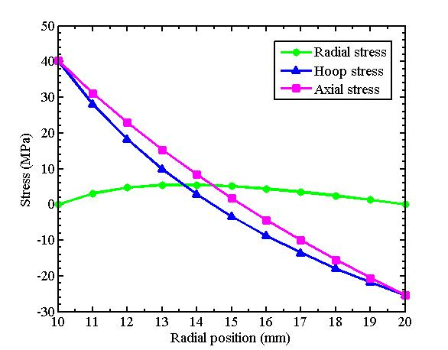
Fig. 1 A sample graph using colors which contrast well both on screen and on a black-and-white hardcopy

Fig. 2 shows an example of a low-resolution image which would not be acceptable, whereas Fig. 3 shows an example of an image with adequate resolution. Check that the resolution is adequate to reveal the important detail in the figure.
Please check all figures in your paper both on screen and on a black-and-white hardcopy. When you check your paper on a black-and-white hardcopy, please ensure that:
- the colors used in each figure contrast well,
- the image used in each figure is clear,
- all text labels in each figure are legible.
- Figure Captions
Figures must be numbered using Arabic numerals. Figure captions must be in 8 pt Bold font. Captions of a single line (e.g. Fig. 2) must be centred whereas multi-line captions must be justified (e.g. Fig. 1). Captions with figure numbers must be placed after their associated figures, as shown in Fig. 1.
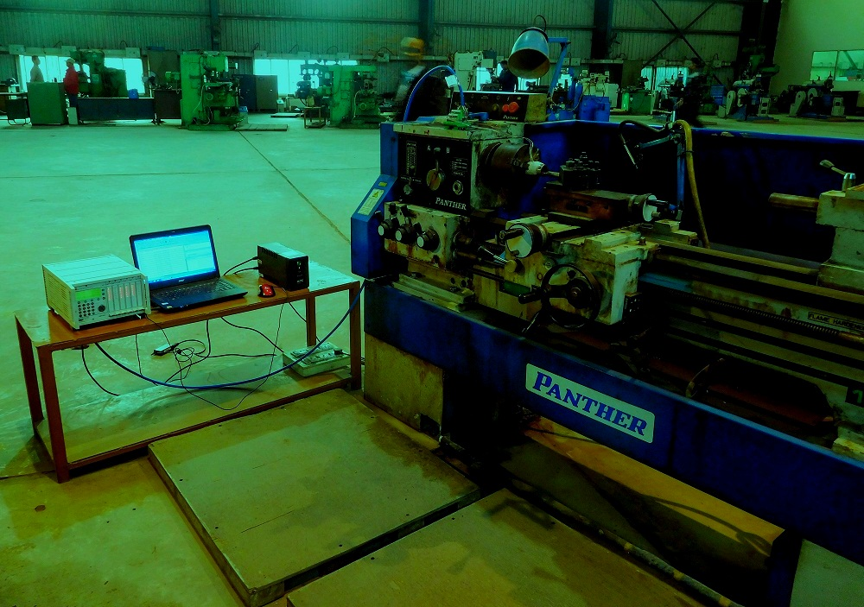
Fig. 2 Example of an unacceptable low-resolution image

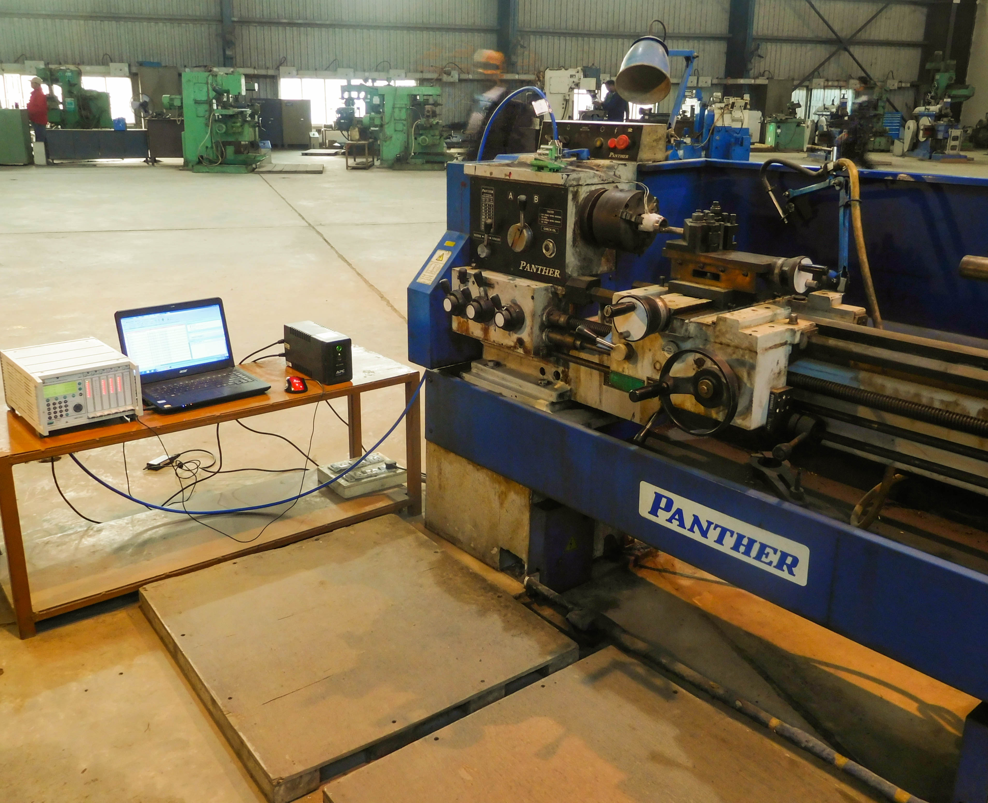
Fig. 3 Example of an image with acceptable resolution
- Table Captions
Tables must be numbered using uppercase Times New Roman numerals. Table captions must be centred and in 8 pt Bold font with Small Caps. Every word in a table caption must be capitalized except for short minor words as listed in Section 3-B. Captions with table numbers must be placed before their associated tables, as shown in Table 1.
- Page Numbers, Headers and Footers
Page numbers, headers and footers must not be used.
- Links and Bookmarks
All hypertext links and section bookmarks will be removed from papers during the processing of papers for publication. If you need to refer to an Internet email address or URL in your paper, you must type out the address or URL fully in Regular font.
- References
The heading of the References section must not be numbered. All reference items must be in 8 pt font. Please use Regular and Italic styles to distinguish different fields as shown in the References section. Number the reference items consecutively in square brackets (e.g. [1]).
When referring to a reference item, please simply use the reference number, as in [2]. Do not use “Ref. [2]” or “Reference [3]” except at the beginning of a sentence, e.g. “Reference [3] shows …”. Multiple references are each numbered with separate brackets (e.g. [2], [3], [4]–[6]).
Examples of reference items of different categories shown in the References section include:
- example of a book in [1]
- example of a journal article in [2]
- example of a conference paper in [3]
- example of a patent in [4]
- example of a technical report in [5]
- example of a standard in [6]
- Conclusions
Conclusion to be based on findings of the work reported in the paper.
Acknowledgment
The heading of the Acknowledgment section and the References section must not be numbered.
References
- Noda, N., Hetnarski, R.B. and Tanigawa, Y., 2003, Thermal stresses, 2nd ed., Taylor and Francis, New York.
- Kamal, S.M. and Dixit, U.S., 2015, Feasibility study of thermal autofrettage of thick-walled cylinders, ASME Journal of Pressure Vessel Technology, 137(6), pp. 061207-1−061207-18.
- Kamal, S.M., Dixit, U.S., Liu, Q., Silberschmidt, V.V. and Roy, A., 2016, Thermo-Elasto-Plastic Finite Element Stress Analysis of Thick-Walled Cylinder and its Comparison with Plane Stress and Plane Strain Analyses, The 12th World Congress on Computational Mechanics (WCCM XII) & The 6th Asia-Pacific Congress on Computational Mechanics (APCOM VI), 24−29 July, Seoul, South Korea.
- Ezra, A., Glick, H., Howell, W. and Kaplan, M., 1973, Method and apparatus for explosive autofrettage, U.S. Patent No. 3751954.
- Lee, S.L., O’Hara, G.P., Olmstead, V. and Capsimalis, G., 1992, Characterization of residual stresses in an eccentric swage autofrettaged thick-walled steel cylinders, Technical report ARCCB-TR-92017, U.S. Army Armament Research development and engineering Center, Benét Laboratories, Watervliet, N.Y. 12189−4050.
- ASME Boiler and Pressure Vessel Code, 2004, Section VIII, Division 3, Article KD-510–530, pp. 104–105.

